Applicant Pack
Assistant Principal- Teaching and Learning
- A welcome from the Principal
- Introduction to Trinity Academy St Edward’s
- Job Description
- Person Specification
ACADEMIC EXCELLENCE, AMAZING EXPERIENCE.

Part of the Trinity family of academies and schools

A welcome from the Principal
I am delighted that you are interested in working at our inimitable academy. Trinity Academy St Edward’s opened our doors in September 2021 to our founding cohort of students. This is an exciting and truly unique opportunity to be a key part of shaping the academy’s journey from the early conception. The academy is part of Trinity Multi Academy Trust and we will be very fortunate to benefit from outstanding support, guidance and resource from our highly successful trust. While benefitting from being part of this family we will continue to embed our culture and ethos from the start, ensuring every child achieves academic excellence and has an amazing experience.
The academy will serve communities from across Barnsley and no matter the starting point of our children we will raise their aspirations and change their futures by achieving outstanding outcomes and creating lifelong memories. Our broad and balanced curriculum, with a STEM focus, will open our students’ eyes to what the world can offer, and genuinely wide ranging extra-curricular experiences will dovetail this.
This is a once in a lifetime opportunity to join the senior leadership team at our brand-new academy. The successful applicant will contribute to further develop the teaching and learning framework that is in its infancy at our school.
Working alongside the senior leaders you will play a significant part in the operational leadership of all aspects of teaching and learning. You will have oversight of the implementation of our Trust Policy but be given the chance to innovate in key areas to ensure our children are immersed in a world class learning environment.
We are looking for a dedicated, passionate and strong leader who has experience in leading aspects of teaching and learning. You will have a thorough understanding of how children learn, how pedagogy plays a vital part in this and be fully up to date with the latest academic research to ensure you lead our staff to deliver a world class learning experience.
As we are a growing academy you will play a significant role in the daily operational working of our school and contribute significantly to the planning and delivery of CPD for our staff.
Alongside all of this, you will be part of a strong leadership team who is committed to changing the lives of our children and a Trust that will invest in your development as a leader.
This is a truly exciting time to be a member of Team Trinity as we start to plan our move to our new £25million, 18-acre, new build in September 2023 where children’s learning and experiences will transform their lives and that of the community.
I am delighted and privileged to lead the academy and serve the communities of Barnsley. I am passionate about the future of the academy, its staff and students, and the change that we can make to the lives of the people of Barnsley. Our values of respect, honesty, empathy and responsibility will embody all we do in creating a happy, successful and ambitious culture at TASE.
Mark Allen
Principal

Trinity Academy St Edward’s
Due to an increase in population in Barnsley, particularly in young people of school age, the need for a new secondary school is prevalent. In 2019, Trinity Multi Academy Trust was selected by the Department for Education as the sponsor for a brand-new school.
Trinity MAT is proud to have transformed the life chances of thousands of students across its existing academies, and we are equipped and eager to do the same for those in Barnsley. Our MAT core values of Empathy, Honesty, Respect and Responsibility run through all aspects of academy life. We welcome students of all faiths and none, these values relate to everyone regardless of faith or background.
Drawing from the success and expertise of organisations across our high performing MAT, we will ensure that children are supported both academically and pastorally to secure the brightest of futures.
Our secondary schools consistently achieve academic results which place them in the top 10% of highest performing schools in the country and receive national and international recognition for the quality of their provision. This success will be replicated at Trinity Academy St Edward’s where every young person will benefit from outstanding teaching and an inspirational curriculum.
For more information about Trinity Academy St Edward’s please visit stedwards.trinitymat.org
For more information about Trinity Multi Academy Trust please visit www.trinitymat.org
‘An academy where ALL are respected and valued.’
We are a courageous, resilient and positive community rooted in hope, aspiration and excellence. Together, we enable each other to be the best we can be.
‘Whatever you do, work heartedly’ Colossians 3:23

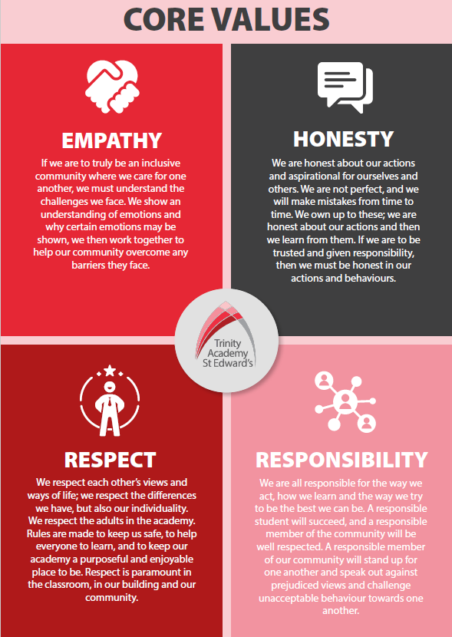

Trinity Academy St Edward’s

Job Description

Job Title: | Assistant Principal (Teaching and Learning)
Job Scale: | Leadership Scale 14-18

BASIC JOB PURPOSE
- To strategically lead the direction and development of the academy in accordance with the ethos and vision of the sponsors.

- To raise standards of student attainment and achievement across the academy by:
- providing strategic and operational leadership for learning and teaching, setting clear direction and effective management for the Academy as a whole
- establishing systems for Quality Assurance to inform the academy improvement plan and establish a positive culture of self-review and improvement
- leading innovation and development of teaching and learning through new technologies and cutting-edge research
- developing and enhancing the teaching practice of others.

- To effectively evaluate the impact on student attainment and achievement above and strategically plan for improvement by contributing to the management and deployment of all financial and physical resources in the academy.

- To support on the new build, ensuring smooth transition via well planned curriculum provision and support, particularly regarding the specialist areas.

Reporting to: | Principal
MAIN RESPONSIBILITIES
1 | To be accountable for the achievement, attainment and progress of students across the academy.
2 | Strategic lead on the development of learning and teaching for all academy staff.
3 | To monitor and evaluate the progress of staff and students towards meeting the overall aims and objectives.
4 | To strategically develop the whole academy use of national initiatives to ensure effective planning for future improvements.
5 | Line Management of identified staff and improvement partner for an identified curriculum area.
6 | To monitor classroom performance and manage interventions and support for children who need extra support.
7 | To be accountable evaluating learning and teaching strategies.
8 | To take a lead role in constantly reviewing and adapting a modern, innovative, and relevant 21st Century curriculum to raise aspiration and achievement.
9 | To create structures to ensure that teaching and learning is innovative and of a high quality throughout the academy.
10 | To contribute towards establishing relevant provision to establish and grow 11-16 provision.
11 | To contribute to developing a programme of enrichment extending the academy experience beyond the limits of formal teaching.
12 | To keep up to date with national developments in pedagogy.
13 | To conduct ‘learning walks’, ‘spotlights’ and other learning evaluation strategies in accordance with academy policy.
14 | To develop a culture of independent learning, and establish and develop the library to promote independent learning for individuals and small groups.
15 | To ensure that new technologies are introduced and deployed effectively across the academy and that pedagogy embraces and develops with available technologies.
16 | To undertake Performance Management Review(s) and to act as reviewer for other academy staff.
17 | To participate in the interview process for teaching posts when required and to ensure effective induction of new staff in line with academy procedures.
18 | To participate in the academy’s ITT programme.
19 | To support development in learning and teaching within and across curriculum areas through designing and leading effective and relevant CPD, and then monitoring and reviewing this.
20 | To support colleagues to be successful in their own leadership role through mentoring, coaching and line management.
21 | To contribute to mentoring/coaching programmes and induction of new staff, GTPs and ECTs.
22 | To evaluate the performance data provided and take appropriate action on issues arising - setting realistic deadlines where necessary and reviewing progress on the action taken.
23 | To provide all relevant bodies with robust information relating to the academy’s performance and development.
24 | To contribute to intervention and mentoring strategies.
25 | To ensure that all members of the academy are familiar with its aims and objectives.
26 | To ensure effective communication/consultation as appropriate with the parents of students and other relevant stakeholders.
27 | To liaise with partner schools, Higher Education Institutions, industrial links, governors and other relevant external bodies.
28 | To represent the academy’s views and interests in a professional manner.
29 | To contribute to academy liaison and marketing activities, e.g. the collection of material for press releases.
30 | To contribute to the development of effective links with partner schools and the community; attendance where necessary at liaison events in partner schools and the effective promotion of subjects at Open Days/Evenings and other events.
31 | To actively promote the development of effective links with external agencies.
32 | To contribute towards a smooth transition on all aspects/liaison with the new building programme, particularly regarding the specialist provision areas.
33 | To act as a Form Tutor and SLT link for a year group and to carry out the duties associated with that role as outlined in the generic job description.
34 | To ensure the Behaviour for Learning strategy is implemented in the academy so that effective learning can take place.
35 | To promote teamwork and to motivate staff to ensure effective working relations.
36 | To be responsible for the day-to-day line management of Curriculum Leaders ensuring that they follow academy policies and meet all requirements and deadlines.

Other Specific Duties:

- All SLT will have generic responsibilities, such as a ‘hands-on’ role in the day-to-day management of the Academy e.g. maintaining a presence around the academy throughout the day. All SLT will also:

- contribute to the strategic leadership and management of the academy in order to develop an ethos and culture of high expectations
- model the ethos and vision for the Academy
- line and performance manage identified staff and teams
- coach and develop the staff and students for which they are accountable.

Many specific responsibilities will require collaborative working with other SLT and middle managers, which the SLT member will develop proactively.

- To uphold and promote the academy’s Christian vision.

- Whilst every effort has been made to explain the main duties and responsibilities of the post, each individual task may not be identified. Employees will be expected to comply with any reasonable request from the principal to undertake work of a similar level that is not specified in this job description.

- This job description is current at the date shown. In consultation with you, it may be changed by the Principal to reflect or anticipate changes in the job commensurate with the grade and job title.

__________________________________________ Post Holder Name

__________________________________________ Post Holder Signature

______________________________________ Date

PPERSON SPECIFICATION
Job Title: Assistant Principal (Teaching and Learning)

KEY CRITERIA | ESSENTIAL | DESIRABLE
Qualifications & Experience | - education to degree level or equivalent  - QTS and GTC registered  - an excellent track record of recent, relevant professional development  - responsibility for an area of whole school performance  - experience of effective teaching and performance within the curriculum area. | - innovative use of resources  - working with young people and inner city communities
Leadership & Management | - experience of working as a strong leader and as a member of a team in and educational setting  - innovative approaches to working with students, parents, staff and other stakeholders  - initiate, lead and manage change programmes  - prioritise, plan and organise  - direct and co-ordinate the work of others  - set high standards and provide a role model for students and staff  - deal sensitively with people and resolve conflicts  - a commitment to an open and collaborative style of management | - motivate all those involved in the delivery team  - liaise effectively with other organisations and agencies
Knowledge & Understanding | - the principles behind the Core Purpose in the JD and their potential for raising standards  - the principles and characteristics of effective academies  - the principles and practices of strategic and operational planning and delivery  - effective review and evaluation procedures | - different methods of consulting with stakeholders  - professional and community links  - the application of ICT to effective management and learning  - strategies for ensuring equal opportunities for staff, students and other stakeholders
Communication Skills | - communicate the vision of the academy to a range of stakeholders  - negotiate and consult fairly and effectively  - develop and manage good communication systems  - communicate effectively orally and in writing to a range of audiences | - develop, maintain and use an effective network of contacts
Decision Making and Judgement Skills | - make decisions based on analysis, interpretation and understanding of relevant data and information  - demonstrate good judgement | - think creatively and imaginatively to anticipate, identify and solve problems
Personal qualities | - a commitment to inclusive education  - evident enjoyment in working with young people and their families  - empathy in relation to the needs of the academy and the local community  - ability to inspire confidence in staff, students, parents and others  - adaptability to changing circumstances/new ideas  - reliability, integrity and stamina  - personal impact and presence  - prioritise and manage own time effectively  - work under pressure and to deadlines  - seek advice and support when necessary | - achieve challenging professional goals  - personal ambition and potential for further promotion  - intellectual ability and curiosity  - determination to succeed and the highest possible expectations of self and others  - vision, imagination and creativity  - resilience and perspective

