Applicant Pack
SENDCo

- A welcome from the Principal
- Introduction to Trinity Academy St Edward’s
- Job Description
- Person Specification
ACADEMIC EXCELLENCE, AMAZING EXPERIENCE.

Part of the Trinity family of academies and schools

A welcome from the Principal
I am delighted that you are interested in working at our inimitable academy. Trinity Academy St Edward’s opened our doors in September 2021 to our founding cohort of students. This is an exciting and truly unique opportunity to be a key part of shaping the academy’s journey from the early conception. The academy is part of Trinity Multi Academy Trust and we will be very fortunate to benefit from outstanding support, guidance and resource from our highly successful trust. While benefitting from being part of this family we will continue to embed our culture and ethos from the start, ensuring every child achieves academic excellence and has an amazing experience.
The academy will serve communities from across Barnsley and no matter the starting point of our children we will raise their aspirations and change their futures by achieving outstanding outcomes and creating lifelong memories. Our broad and balanced curriculum, with a STEM focus, will open our students’ eyes to what the world can offer, and genuinely wide ranging extra-curricular experiences will dovetail this.
The role of SENDCo will play a key part of shaping the academy’s future. We are looking for a dedicated, passionate, and strong leader with a successful track record of leading SEND and inclusion, with demonstrable impact on students’ lives. You will have operational oversight of all the SEND provision in the academy and help to shape a bespoke curriculum for children who may need extra support. You will quality assure the work of our teachers in the classroom, ensuring that quality first teaching is at the heart of our offer. As we grow year on year, you will be responsible for ensuring our children’s needs are met fully in and out of the classroom and you will decide upon the strategy of in-class support. Transition plays an important part in the role, and you will work closely with our primary schools to develop positive working relationships and ensure that all School Focused Plans and EHCPs are secondary appropriate. You will play an instrumental part in the training and development of our staff, using your expertise and that of others, to ensure we train them to be the very best in supporting children with identified difficulties in our academy. You will work closely with the pastoral team and triangulate the impact of learning, behaviour, and special needs. You be part of safeguarding team and be the nominated person for Looked After Children. This role will ensure you become part of the heartbeat of the inclusion systems in the academy. Inclusion is the centre of all we do at Trinity Academy St Edward’s, this role ensures the successful applicant becomes a key cog in our children’s future successes.
We welcome applications from both secondary and primary colleagues. We will only have two-year groups when the role starts, so expertise in primary pedagogy, particularly the core subjects, would help the successful applicant in the role as would secondary pedagogy and experience.
I am delighted and privileged to lead the academy and serve the communities of Barnsley. I am passionate about the future of the academy, its staff and students, and the change that we can make to the lives of the people of Barnsley. Our values of respect, honesty, empathy and responsibility will embody all we do in creating a happy, successful and ambitious culture at TASE.
Mark Allen
Principal

Trinity Academy St Edward’s
Due to an increase in population in Barnsley, particularly in young people of school age, the need for a new secondary school is prevalent. In 2019, Trinity Multi Academy Trust was selected by the Department for Education as the sponsor for a brand-new school.
Trinity MAT is proud to have transformed the life chances of thousands of students across its existing academies, and we are equipped and eager to do the same for those in Barnsley. Our MAT core values of Empathy, Honesty, Respect and Responsibility run through all aspects of academy life. We welcome students of all faiths and none, these values relate to everyone regardless of faith or background.
Drawing from the success and expertise of organisations across our high performing MAT, we will ensure that children are supported both academically and pastorally to secure the brightest of futures.
Our secondary schools consistently achieve academic results which place them in the top 10% of highest performing schools in the country and receive national and international recognition for the quality of their provision. This success will be replicated at Trinity Academy St Edward’s where every young person will benefit from outstanding teaching and an inspirational curriculum.
For more information about Trinity Academy St Edward’s please visit stedwards.trinitymat.org
For more information about Trinity Multi Academy Trust please visit www.trinitymat.org
‘An academy where ALL are respected and valued.’
We are a courageous, resilient and positive community rooted in hope, aspiration and excellence. Together, we enable each other to be the best we can be.
‘Whatever you do, work heartedly’ Colossians 3:23

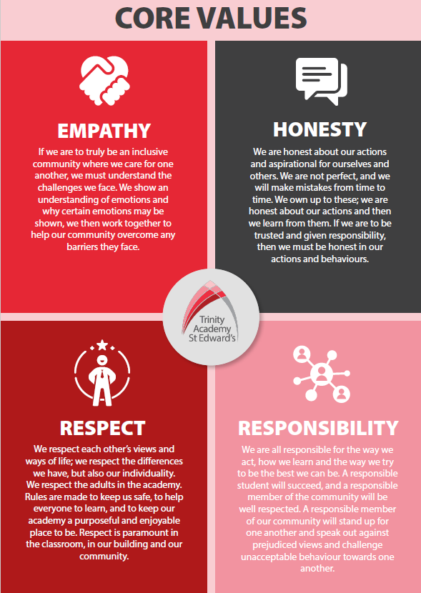

Trinity Academy St Edward’s

Job Description
Post Title: | SENDCo
Salary: | L1-L10
Core Purpose: | - To lead the direction and development of inclusion and SEND provision in accordance with the aims and objectives of the academy.  - To raise standards of student attainment and achievement across the academy by:  - liaising with other leaders to ensure the provision of an appropriately relevant and differentiated curriculum for inclusive learning.  - providing strategic leadership for all aspects of inclusive education.  - developing systems and enhancing student engagement  - developing effective partnerships with all Children’s Services  - ensuring high quality SEND provision that links cohesively to pastoral strategies and safeguarding practices  - developing and enhancing the teaching practice of others.  - To effectively evaluate the impact of (b) and strategically plan for improvement by managing and deploying all financial and physical resources within the area.
Reporting to  Responsible for: | Principal  Learning Support team
Liaising with | SLT, other Curriculum Leaders, Deputy Curriculum Leaders, Lead Teacher team, Phase Leaders, the learning support team and other relevant staff with cross-academy responsibilities, partner primary schools, other academy partners and parents.
Leadership | - To provide the strategic leadership for inclusion provision in accordance with the aims and objectives of the academy. This includes undertaking the role of SEND Co-ordinator  - To be accountable for the attainment and progress of SEND and LAC students (including the named LAC officer).  - To be accountable for developing inclusive learning strategies that complement the academy’s Behaviour for Learning (BfL) strategy and promotes a vibrant learning environment throughout the academy.  - To lead the academy’s strategies for supporting students with medical needs.  - Working in partnership with leaders by supporting and developing intervention strategies and evaluation of their impact on the day-to-day running of the academy.  - To be accountable for the development of effective partnerships with all Children’s Services.  - To lead on the strategic development of student welfare and inclusion services.  - To be accountable for the establishment and effectiveness of the policies and procedures needed to achieve these aims and objectives.  - To be responsible for the management of resources to ensure that the aims and objectives can be achieved.  - To link with the other leaders to ensure that the academy’s inclusive education provision fully reflects the academy's distinctive ethos and mission.
Curriculum | - To lead curriculum development for the whole inclusion provision e.g. alternative curriculum pathways.  - To source, monitor and evaluate any alternative provision that is required and ensure it provides the highest education, safety and value for money.  - To liaise with the appropriate member of SLT to ensure the delivery of an appropriate, high quality curriculum programme which meets the needs of all students.  - To actively monitor and respond to curriculum development and initiatives at national, regional and local levels.  - To lead the development of appropriate syllabi, resources, SoW, assessment policies, and learning and teaching strategies in the area.  - To maintain accreditation with the relevant examination and validating bodies.  - To lead the assessment of and to source all exam access requirements and ensure they are implemented.  - To develop an effective literacy programme to allow those students as identified as needing ‘catch-up’ to do so.  - To develop and implement an internal provision that meets the academic and SEMH needs of those students who may require extra support and a more personalised timetable. To develop the curriculum, pedagogy and assessment of this provision.
Learning | - To lead on the effective provision of inclusive education, including the CPD of all staff; developing and enhancing the teaching practice of all colleagues, implementing improvements where required.  - To establish common standards of practice within the area and develop the effectiveness of teaching and learning styles.  - To keep up to date with national developments in teaching practice and methodology.  - To conduct ‘learning walks’ and other learning evaluation strategies in accordance with academy policy, ensuring all SEND students’ needs are consistently met in the classroom.
Staff Development | - To work with the SLT Line Manager to ensure that staff development needs are identified and that appropriate programmes are designed and delivered to meet such needs.  - To undertake Performance Management Review(s) and to act as reviewer for identified staff.  - To participate in the interview process for teaching posts when required and to ensure effective induction of new staff in line with academy procedures.  - To be responsible for the efficient and effective deployment of relevant learning support staff.  - To participate in the academy’s ITT programme.
Assessment | - To establish a robust target-setting process within the academy.  - To evaluate the performance data provided and take appropriate action on issues arising - setting realistic deadlines where necessary and reviewing progress on the action taken.  - To produce reports on examination performance, including the use of value-added data.  - To provide all relevant bodies with robust information relating to the SEND students’ performance and development.
Communication | - To ensure that all team members are familiar with the aims and objectives of the SEND team.  - To ensure effective communication/consultation as appropriate with the parents of students and other relevant stakeholders.  - To liaise with partner schools, Higher Education Institutions, industrial links, Examination Boards/Awarding Bodies and other relevant external bodies.  - To represent the academy’s views and interests in a professional manner.  - To lead on transition of SEND students’ from Y6/Y7 and Y11/12 ensuring regular, robust and open communication between settings.
Marketing and Liaison | - To contribute to academy liaison and marketing activities, e.g. the collection of material for press releases.  - To lead the development of effective subject links with partner schools and the community; attendance where necessary at liaison events in partner schools and the effective promotion of subjects at Open Days/Evenings and other events.  - To actively promote the development of effective subject links with external agencies.
Management of Resources | - To efficiently manage the available resources of space, staff, finance and equipment within the limits, guidelines and procedures laid down; to deploy any relevant budgets, acting as a cost centre holder, ensuring that equipment and stock is requisitioned, organised and maintained, and appropriate records are kept.  - To work with the SLT to ensure that the areas teaching commitments are effectively and efficiently timetabled.
Pastoral System | - To monitor and support the overall progress and development of all academy students.  - To monitor student attendance and progress in relation to targets set for each individual, ensuring that appropriate action is taken where necessary.  - To act as a Form Tutor (when required) and to carry out the duties associated with that role as outlined in the generic job description.  - To ensure the Behaviour for Learning Policy is implemented in the academy so that effective learning can take place.
Operational | - To promote teamwork and to motivate staff to ensure effective working relations.  - To be responsible for the day-to-day line management of staff within the academy, ensuring that they follow academy policies and meet all requirements and deadlines  - To make appropriate arrangements for classes when staff are absent, liaising with the Cover Supervisor/relevant staff where appropriate.
Other Specific Duties
Whilst every effort has been made to explain the main duties and responsibilities of the post, each individual task may not be identified. Employees will be expected to comply with any reasonable request from the principal to undertake work of a similar level that is not specified in this job description.
This job description is current at the date shown. It will be reviewed at least annually and, in consultation with you, it may be changed by the Principal to reflect or anticipate changes in the job commensurate with the grade and job title.

__________________________________________ Post Holder Name

__________________________________________ Post Holder Signature

__________________________________________ Principal signature

__________________________________________ Date

PPERSON SPECIFICATION
Job Title: SENDCo
KEY CRITERIA | ESSENTIAL | DESIRABLE
Qualifications & Experience | - education to degree level or equivalent with QTS  - an excellent track record of recent, relevant professional development  - accountability for the performance of a significant cohort of SEND students  - Experience in developing curriculum and practices to support students with ASC.  - evidence of good/outstanding classroom practice  - taking accountability for the success of an initiative  - leadership of a community project or an area of school development  - experience of raising standards and performance of a significant cohort of SEND students | - innovative use of resources  - working with young people and disadvantaged communities  - qualifications and training related to supporting students with ASC
Knowledge & Understanding | - innovative approaches to working with students, parents, staff and the local community  - the principles and practices of strategic and operational planning and delivery  - an understanding of SEND issues, policies and procedures  - effective review and evaluation procedures  - the application of ICT to effective management | - different methods of consulting with stakeholders  - community/voluntary/parent/partner agency links  - strategies for ensuring equal opportunities for staff, students, and other stakeholders
Leadership & Management | - work effectively both as a leader and as a member of a team  - To uphold and promote the academy’s Christian vision  - initiate, lead and manage change  - prioritise, plan and organise  - direct and co-ordinate the work of others  - set high standards and provide a role model for students and staff  - deal sensitively with people and resolve conflicts  - seek advice and support when necessary  - prioritise and manage own time effectively  - a commitment to an open and collaborative style of management | - motivate all those involved in the delivery team  - liaise effectively with other organisations and agencies
Communication Skills | - communicate the vision of the academy in relation to the development of the local community  - negotiate and consult fairly and effectively  - build relationships with key stakeholders  - ability to communicate to a range of audiences.  - chair meetings effectively  - communicate effectively orally and in writing to a range of audiences | - develop, maintain and use an effective network of contacts
Decision Making Skills | - make decisions based on analysis, interpretation and understanding of relevant data and information  - demonstrate good judgement | - think creatively and imaginatively to anticipate, identify and solve problems
Personal Qualities | - a commitment to inclusive education  - evident enjoyment in working with young people and their families  - empathy in relation to the needs of the academy and the local community  - ability to inspire confidence in staff, students, parents and others  - adaptability to changing circumstances/new ideas  - reliability, integrity and stamina  - personal impact and presence  - work under pressure and to deadlines | - vision, imagination and creativity  - a commitment to professional development

