Applicant Pack
Teacher – Science
- A welcome from the Principal
- Introduction to Trinity Academy St Edward’s
- Job Description
- Person Specification
ACADEMIC EXCELLENCE, AMAZING EXPERIENCE.

Part of the Trinity family of academies and schools

A welcome from the Principal
I am delighted that you are interested in working at our inimitable academy. Trinity Academy St Edward’s opened our doors in September 2021 to our founding cohort of students. This is an exciting and truly unique opportunity to be a key part of shaping the academy’s journey from the early conception. The academy is part of Trinity Multi Academy Trust and we will be very fortunate to benefit from outstanding support, guidance and resource from our highly successful trust. While benefitting from being part of this family we will continue to embed our culture and ethos from the start, ensuring every child achieves academic excellence and has an amazing experience.
The academy will serve communities from across Barnsley and no matter the starting point of our children we will raise their aspirations and change their futures by achieving outstanding outcomes and creating lifelong memories. Our broad and balanced curriculum, with a STEM focus, will open our students’ eyes to what the world can offer, and genuinely wide ranging extra-curricular experiences will dovetail this.
The role of teacher of Science is such an exciting opportunity to contribute to a successful team as it continues to establish itself within our wonderful academy. The successful applicant will be part of a team and will have the chance to actively contribute to curriculum development and further enhance our already successful department through excellent teaching, learning and assessment.
You will be able to access our bookletised curriculum and contribute to its development across three schools in our Trust and we will offer you effective and personalised CPD to enhance your pedagogical knowledge. Alongside all of this you will be able to plan the transition for the opening of our £25million, 18-acre new build in September 2023. This really is a once in a lifetime opportunity to help shape the future of children’s lives in a warm, welcoming and child focused setting.
I am delighted and privileged to lead the academy and serve the communities of Barnsley. I am passionate about the future of the academy, its staff and students, and the change that we can make to the lives of the people of Barnsley. Our values of respect, honesty, empathy and responsibility will embody all we do in creating a happy, successful and ambitious culture at TASE.
Mark Allen
Principal

Trinity Academy St Edward’s
Due to an increase in population in Barnsley, particularly in young people of school age, the need for a new secondary school is prevalent. In 2019, Trinity Multi Academy Trust was selected by the Department for Education as the sponsor for a brand-new school.
Trinity MAT is proud to have transformed the life chances of thousands of students across its existing academies, and we are equipped and eager to do the same for those in Barnsley. Our MAT core values of Empathy, Honesty, Respect and Responsibility run through all aspects of academy life. We welcome students of all faiths and none, these values relate to everyone regardless of faith or background.
Drawing from the success and expertise of organisations across our high performing MAT, we will ensure that children are supported both academically and pastorally to secure the brightest of futures.
Our secondary schools consistently achieve academic results which place them in the top 10% of highest performing schools in the country and receive national and international recognition for the quality of their provision. This success will be replicated at Trinity Academy St Edward’s where every young person will benefit from outstanding teaching and an inspirational curriculum.
For more information about Trinity Academy St Edward’s please visit stedwards.trinitymat.org
For more information about Trinity Multi Academy Trust please visit www.trinitymat.org
‘An academy where ALL are respected and valued.’
We are a courageous, resilient and positive community rooted in hope, aspiration and excellence. Together, we enable each other to be the best we can be.
‘Whatever you do, work heartedly’ Colossians 3:23

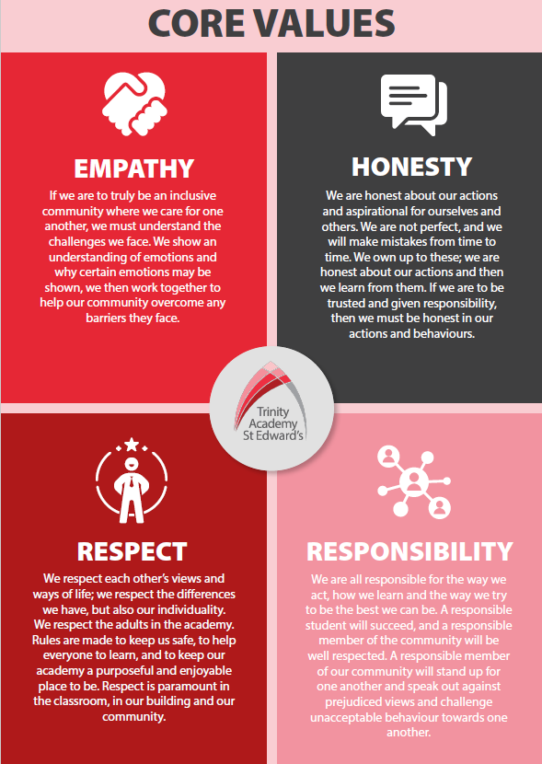

Trinity Academy St Edward’s

Job Description

Job Title: | Teacher
Job Scale: | MPR/UPR

BASIC JOB PURPOSE
- To support the work of the curriculum leadership team to implement and deliver an appropriately broad, balanced, relevant and differentiated curriculum for students, supporting the curriculum area, in accordance with the aims and objectives of the academy.
- To contribute to raising standards of attainment and achievement by monitoring and supporting student progress, and developing students as a teacher and tutor.
- To facilitate and encourage a learning experience which provides opportunities for students to achieve their potential.
- To share and support the academy’s responsibility to provide and monitor opportunities for personal and academic growth and success.

Reporting to: | Curriculum Leader or Subject Co-ordinator
MAIN RESPONSIBILITIES

1 | To assist in the development of appropriate syllabuses, resources, schemes of work, marking policies and teaching strategies in the Curriculum Area (CA).
2 | To contribute to the CA’s improvement plan and its implementation.

Trinity Academy St Edward’s

Job Description

Job Title: | Teacher
Job Scale: | MPR/UPR

BASIC JOB PURPOSE

- To support the work of the curriculum leadership team to implement and deliver an appropriately broad, balanced, relevant and differentiated curriculum for students, supporting the curriculum area, in accordance with the aims and objectives of the academy.
- To contribute to raising standards of attainment and achievement by monitoring and supporting student progress, and developing students as a teacher and tutor.
- To facilitate and encourage a learning experience which provides opportunities for students to achieve their potential.
- To share and support the academy’s responsibility to provide and monitor opportunities for personal and academic growth and success.

Reporting to: | Curriculum Leader or Subject Co-ordinator
MAIN RESPONSIBILITIES

1 | To assist in the development of appropriate syllabuses, resources, schemes of work, marking policies and teaching strategies in the Curriculum Area (CA).
2 | To contribute to the CA’s improvement plan and its implementation.
3 | To undertake a designated programme of teaching and to plan and prepare courses and lessons.
4 | To contribute to the whole academy’s planning activities.
5 | To participate in ‘learning walks’ and other learning evaluation strategies in accordance with academy policy.
6 | Implementing academy policies relevant to teaching and learning, including behaviour, homework and assessment.
7 | To teach students according to their educational needs, including the setting and marking of work to be carried out by the students in the academy and elsewhere.
8 | To assess, record and report on the attendance, progress, development and attainment of students and to keep such records as are required.
9 | To provide, or contribute to, oral and written assessments, reports and references relating to individual students and groups of students.
10 | To ensure that ICT, Literacy, Numeracy and cross-curricular themes are reflected in the teaching/learning experience of students.
11 | To ensure a high quality learning experience for students which meets internal and external quality standards.
12 | To prepare and update subject materials.
13 | To use a variety of delivery methods which will stimulate learning appropriate to student needs and demands of the syllabus.
14 | To maintain discipline in accordance with the academy’s procedures, and to encourage good practice with regard to punctuality, behaviour, standards of work and homework.
15 | To assist in the process of curriculum development and improvement planning.
16 | To support, change and develop the curriculum to ensure the continued relevance to the needs of students, examining and awarding bodies and the academy’s aims and objectives.
17 | To assist the CL and DCL to ensure that the curriculum area provides a range of teaching that complements the academy’s strategic objectives.
18 | To support the academy’s extra-curricular offer.
19 | To help to implement academy quality assurance procedures and to adhere to those.
20 | To contribute to the process of monitoring and evaluation of the curriculum area, in line with agreed academy procedures, including evaluation against quality standards and performance criteria. To seek/implement modification and improvement where required.
21 | To review from time to time methods of teaching and programmes of work.
22 | To take part, as may be required, in the review, development and management of activities relating to the curriculum, organisation and pastoral functions of the school.
23 | To maintain appropriate records and to provide relevant accurate and up-to-date information for the academy’s MIS.
24 | To complete the relevant documentation to assist in the tracking of students.
25 | To track student progress and use information to inform learning and teaching.
26 | To mark, grade and give written/verbal and diagnostic feedback as required.
27 | To undertake assessment of students as requested by external examination bodies, departmental and academy procedures.
28 | To support the establishment of a robust target-setting process within the curriculum area.
29 | Where appropriate, provide all relevant bodies with robust information relating to student performance and assessment.
30 | To engage actively in performance management review(s).
31 | To participate in the academy’s ITT programme where appropriate.
32 | To take part in the academy’s staff development programme by participating in arrangements for further training and professional development.
33 | To continue personal development in the relevant areas including subject knowledge and teaching methods.
34 | To work as a member of the curriculum team and contribute positively to effective working relations within the academy.
35 | To participate in the interview process for teaching posts when required and to support the induction processes for new staff within the team.
36 | To communicate effectively with the parents of students, as appropriate.
37 | Where appropriate, to communicate, and represent the views, of the academy, in a professional manner.
38 | To follow agreed policies for communications in the academy.
39 | To take part in marketing and liaison activities such as Open Evenings, Parents’ Evenings and liaison events with partner institutions.
40 | To contribute to the development of effective subject links with external agencies.
41 | To assist the curriculum leaders to identify resource needs and to contribute to the efficient/effective use of physical resources.
42 | To co-operate with other staff to ensure a sharing and effective usage of resources to the benefit of the academy, curriculum area and the students.
43 | To look after academy equipment and resources allocated to the teacher and the teacher’s teaching area (classroom/workshop/lab etc)
44 | To evaluate and monitor the progress of students and keep up-to-date student records as may be required.
45 | To contribute to the preparation of education plans, progress files and other reports.
46 | To alert the appropriate staff to problems experienced by students and to make recommendations as to how these may be resolved.
47 | To communicate as appropriate, with the parents of students and with persons or bodies outside the school concerned with the welfare of individual students, after consultation with the appropriate staff
48 | To contribute to PSHE/Citizenship and enterprise activities according to academy policy.
49 | To be a Form Tutor to an assigned group of students.
50 | To promote the general progress and well-being of individual students and of the Form Tutor group as a whole.
51 | To liaise with College Mangers and Curriculum Leaders to ensure the implementation of the academy’s Pastoral System.
52 | To register students accurately, accompany them to assemblies and supervise them in assembly, encourage their full attendance at all lessons and their participation in other aspects of academy life.
53 | To promote teamwork and to motivate staff to ensure effective working relations.

Other Specific Duties:

- All teachers are expected to meet the Teachers Standards, and demonstrate consistently high standards of personal and professional conduct, uphold public trust in the profession and maintain high standards of ethics and behaviour, within and outside school.

- To uphold and promote the academy’s Christian vision.

- Whilst every effort has been made to explain the main duties and responsibilities of the post, each individual task may not be identified. Employees will be expected to comply with any reasonable request from the principal to undertake work of a similar level that is not specified in this job description.

- This job description is current at the date shown. In consultation with you, it may be changed by the Principal to reflect or anticipate changes in the job commensurate with the grade and job title.

__________________________________________ Post Holder Name

__________________________________________ Post Holder Signature

______________________________________ Date

PERSON SPECIFICATION
Job Title: Teacher
KEY CRITERIA | ESSENTIAL | DESIRABLE
Qualifications & Experience | - education to degree level or equivalent  - QTS/QTLS and GTC registered  - an excellent track record of recent, relevant professional development  - accountability for the performance of a cohort of young people  - experience of effective teaching and performance within the curriculum area | - innovative use of resources  - working with young people and inner city communities  - leadership of a community project or an area of school development  - taking accountability for the success of an initiative
Knowledge & Understanding | - the principles behind quality teaching and learning their potential for raising standards  - the principles and characteristics of effective academies  - the principles and practices of planning and delivery  - effective review and evaluation procedures  - the application of ICT, Literacy and Numeracy to effective teaching | - community/voluntary/parent/ partner agency links  - strategies for ensuring equal opportunities for staff, students and other stakeholders  - innovative approaches to working with students, parents, staff and the local community
Personal Qualities | - a commitment to inclusive education  - evident enjoyment in working with young people and their families  - empathy in relation to the needs of the academy and the local community  - ability to inspire confidence in staff, students and parents  - set high standards and provide a role model for students and staff  - adaptability to changing circumstances/new ideas | - personal ambition and potential for further promotion  - intellectual ability and curiosity  - determination to succeed and the highest possible expectations of self and others  - vision, imagination and creativity  - personal impact and presence  - an excellent record of attendance and punctuality
Communication Skills | - communicate the vision of the academy in relation improvement plans  - communicate effectively orally and in writing to a range of audiences | - develop, maintain and use an effective network of contacts
Decision Making Skills | - make decisions based on analysis, interpretation and understanding of relevant data and information  - demonstrate good judgement | - think creatively and imaginatively to anticipate, identify and solve problems
Self Management Skills | - prioritise and manage own time effectively  - work under pressure and to deadlines  - reliability, integrity and stamina  - resilience and perspective | - achieve challenging professional goals  - take responsibility for own professional development
Team Working skills | - work effectively as a member of a team  - deal sensitively with people and resolve conflicts  - seek advice and support when necessary | - motivate all those involved in the delivery team  - liaise effectively with other organisations and agencies

