Applicant Pack
Student Progress Leader – Religious Studies and PSHE
- A welcome from the Principal
- Introduction to Trinity Academy St Edward’s
- Job Description
- Person Specification
ACADEMIC EXCELLENCE, AMAZING EXPERIENCE.
Part of the Trinity family of academies and schools

A welcome from the Principal
I am delighted that you are interested in working at our inimitable academy. Trinity Academy St Edward’s opened our doors in September 2021 to our founding cohort of students. This is an exciting and truly unique opportunity to be a key part of shaping the academy’s journey from the early conception. The academy is part of Trinity Multi Academy Trust and we will be very fortunate to benefit from outstanding support, guidance and resource from our highly successful trust. While benefitting from being part of this family we will continue to embed our culture and ethos from the start, ensuring every child achieves academic excellence and has an amazing experience.
The academy will serve communities from across Barnsley and no matter the starting point of our children we will raise their aspirations and change their futures by achieving outstanding outcomes and creating lifelong memories. Our broad and balanced curriculum, with a STEM focus, will open our students’ eyes to what the world can offer, and genuinely wide ranging extra-curricular experiences will dovetail this.
The role of student progress leader for religious studies and PHSE will play a significant part in the continual development of our Humanities Department.
Alongside this, the successful applicant will work closely with the Principal and Chaplain on developing and embedding our Christian Vision and how religious studies permeates throughout our curriculum.
We are looking for an ambitious, passionate and strong leader who will deliver only the very best for our children and contribute to our Team Trinity family.
This is a once in a lifetime opportunity to be part of a special journey and will allow the successful applicant to develop and embed an outstanding and ambitious curriculum dovetailed with providing amazing experiences for our children.
I am delighted and privileged to lead the academy and serve the communities of Barnsley. I am passionate about the future of the academy, its staff and students, and the change that we can make to the lives of the people of Barnsley. Our values of respect, honesty, empathy and responsibility will embody all we do in creating a happy, successful and ambitious culture at TASE.
Mark Allen
Principal

Trinity Academy St Edward’s
Due to an increase in population in Barnsley, particularly in young people of school age, the need for a new secondary school is prevalent. In 2019, Trinity Multi Academy Trust was selected by the Department for Education as the sponsor for a brand-new school.
Trinity MAT is proud to have transformed the life chances of thousands of students across its existing academies, and we are equipped and eager to do the same for those in Barnsley. Our MAT core values of Empathy, Honesty, Respect and Responsibility run through all aspects of academy life. We welcome students of all faiths and none, these values relate to everyone regardless of faith or background.
Drawing from the success and expertise of organisations across our high performing MAT, we will ensure that children are supported both academically and pastorally to secure the brightest of futures.
Our secondary schools consistently achieve academic results which place them in the top 10% of highest performing schools in the country and receive national and international recognition for the quality of their provision. This success will be replicated at Trinity Academy St Edward’s where every young person will benefit from outstanding teaching and an inspirational curriculum.
For more information about Trinity Academy St Edward’s please visit stedwards.trinitymat.org
For more information about Trinity Multi Academy Trust please visit www.trinitymat.org
‘An academy where ALL are respected and valued.’
We are a courageous, resilient and positive community rooted in hope, aspiration and excellence. Together, we enable each other to be the best we can be.
‘Whatever you do, work heartedly’ Colossians 3:23

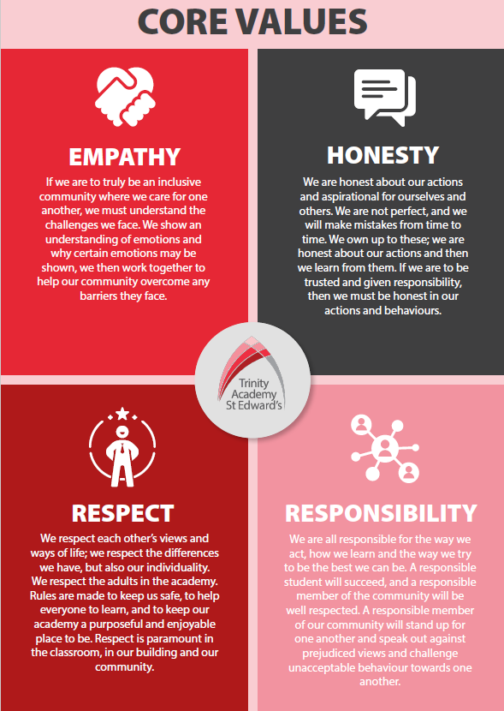

Trinity Academy St Edward’s

Job Description

Job Title: | Student Progress Leader
Job Scale: | MPR/UPR plus TLR

BASIC JOB PURPOSE
- To support the work of the Curriculum Leader/SLT link to raise standards of student attainment and achievement by developing and enhancing the teaching practice of others.

- To support the work of the Curriculum Leader/SLT link to effectively evaluate the impact of the above and strategically plan for improvement in the quality of pedagogy across the academy/school.

- To support the work of the Curriculum Leader/SLT link to research, plan and deliver CPD programmes to support both of the above objectives.

- To lead on curriculum area student support strategies and relevant administration, as directed by the Curriculum Leader/SLT link

- To work across all curriculum areas and develop own practice and knowledge.

Reporting to: | Curriculum Leader (CL)/SLT link
MAIN RESPONSIBILITIES
1 | To support the CL/SLT link to plan and deliver student support strategies, as appropriate to meet curriculum area and academy/school aims and objectives.
2 | To be responsible for effective data management and interrogation to plan support strategies and coordinate as required.
3 | To contribute to the monitoring and evaluation of the progress of staff and students towards meeting the overall aims and objectives.
4 | To be responsible for the establishment and effectiveness of policies and procedures needed for successful student support programmes.
5 | To support the CL/SLT Link in the distribution of resources to ensure that the aims and objectives can be achieved.
6 | To be responsible for student attainment and staff performance in the area.
7 | To support the CL/SLT link to strategically plan for future improvements.
8 | To coordinate administration (relevant to delivering the curriculum), as directed by the CL/SLT link.
9 | To link with the CL/SLT link to ensure that the work in the curriculum area fully reflects the academy/school's vision.
10 | To support professional development of colleagues within the curriculum areas, and across the academy/school.
11 | To promote excellence in the classroom by researching and developing excellent pedagogical practice.
12 | To establish common standards of practice and develop the effectiveness of student support programmes strategies across curriculum areas
13 | To keep up to date with national developments in teaching practice and methodology.
14 | To support ‘learning walks’ and other learning evaluation strategies in accordance with academy/school policy.
15 | To support the development of literacy; numeracy and other initiatives.
16 | To work with the CL/SLT link to ensure that staff development needs are identified and that appropriate programmes are designed to meet such needs.
17 | To support, and where appropriate deliver, CPD events through INSET, or other CPD meetings.
18 | To direct, coach or train staff, as required, to ensure successful delivery of student support programmes.
19 | To observe and feedback to other practitioners on their strengths and areas of development, through agreed ‘learning walk’ programmes.
20 | To research, pilot and deliver student support programmes, teaching and learning strategies and communicate their success through appropriate channels.
21 | To welcome other practitioners to observe lessons.
22 | To participate, and support, in the interview process for teaching posts when required and to ensure effective induction of new staff in line with academy/school procedures.
23 | To participate in teacher training programmes, and ECT induction programme, where appropriate.
24 | To support the establishment of robust assessment and evaluation processes to establish successes and improvements.
25 | To contribute to accurate and effective monitoring information that influences whole academy/school teaching and learning strategies.
26 | To contribute to the evaluation of performance data and support appropriate actions on issues arising - setting realistic deadlines where necessary and reviewing progress on the action taken.
27 | To produce reports on progress of student support strategies, including the use of appropriate data.
28 | To coordinate the effective administration of coursework and examination board requirements, as directed by the CL/SLT link.
29 | To ensure that all members of the curriculum leadership teams are familiar with the aims and objectives of student support programmes.
30 | To ensure effective communication/consultation as appropriate with SLT, CL and other relevant stakeholders.
31 | To liaise with partner schools, Higher Education Institutions, industrial links, Examination Boards/Awarding Bodies and other relevant external bodies.
32 | To represent the academy/school’s views and interests in a professional manner.
33 | To efficiently manage the available resources of space, staff, finance and equipment within the limits, guidelines and procedures laid down; to ensure that equipment and stock is requisitioned, organised and maintained, and appropriate records are kept.
34 | To develop the use of resources (technology, financial) to improve teaching and learning across the academy/school.
35 | To monitor and support the overall progress and development of students within the subject area.
36 | To monitor student attendance and progress in relation to targets set for each individual, ensuring that appropriate action is taken where necessary.
37 | To act as a form tutor and to carry out the duties associated with that role as outlined in the generic job description.
38 | To ensure the Behaviour for Learning System is implemented in the subject area so that effective learning can take place.
39 | To promote teamwork and to motivate staff to ensure effective working relations.
40 | To support the CL/SLT link in the day-to-day line management of staff within the subject area, ensuring that they follow academy/school policies and meet all requirements and deadlines
41 | To support the CL/SLT link to make appropriate arrangements for classes when staff are absent, liaising with the Cover Supervisor/relevant staff where appropriate.

Other Specific Duties:

- All teachers are expected to meet the Teachers Standards, and demonstrate consistently high standards of personal and professional conduct, uphold public trust in the profession and maintain high standards of ethics and behaviour, within and outside school.

- To uphold and promote the academy’s Christian vision.

- Whilst every effort has been made to explain the main duties and responsibilities of the post, each individual task may not be identified. Employees will be expected to comply with any reasonable request from the principal to undertake work of a similar level that is not specified in this job description.

- This job description is current at the date shown. In consultation with you, it may be changed by the Principal to reflect or anticipate changes in the job commensurate with the grade and job title.

__________________________________________ Post Holder Name

__________________________________________ Post Holder Signature

______________________________________ Date

PERSON SPECIFICATION
Job Title: Student Progress Leader

KEY CRITERIA | ESSENTIAL | DESIRABLE
Qualifications & Experience | - MPR/UPR teacher  - an excellent track record of recent, relevant professional development  - accountability for the performance of a cohort of young people  - evidence of good/outstanding classroom practice  - clear demonstration of the ability to coach/model best learning experiences to other teachers and staff  - leadership of a community project or an area of school development | - innovative use of resources  - taking accountability for the success of an initiative
Knowledge & Understanding | - the principles and characteristics of good or better teaching  - effective review and evaluation procedures  - the application of ICT within teaching  - innovative approaches to working with students, parents, staff and the local community  - an understanding of inclusive education | - different methods of consulting with stakeholders
Personal Qualities | - ability to inspire confidence in staff, students, parents and others  - adaptability to changing circumstances/new ideas  - reliability, integrity and stamina  - vision, imagination and creativity | - personal ambition and potential for further promotion  - determination to succeed and the highest possible expectations of self and others
Leadership & Management | - work effectively both as a leader and as a member of a team  - initiate, lead and manage change  - prioritise, plan and organise  - set high standards and provide a role model for students and staff  - deal sensitively with people and resolve conflicts  - seek advice and support when necessary | - motivate all those involved in the delivery team  - liaise effectively with other organisations and agencies
Communication Skills | - communicate the vision of the academy/school in relation to the development of teaching and learning  - negotiate and consult fairly and effectively  - communicate effectively orally and in writing to a range of audiences | - develop, maintain and use an effective network of contacts
Decision Making Skills | - make decisions based on analysis, interpretation and understanding of relevant data and information  - demonstrate good judgement | - think creatively and imaginatively to anticipate, identify and solve problems
Self Management Skills | - prioritise and manage own time effectively  - work under pressure and to deadlines | - achieve challenging professional goals  - take responsibility for own professional development

