Applicant Pack
Subject Co-ordinator – Music
- A welcome from the Principal
- Introduction to Trinity Academy St Edward’s
- Job Description
- Person Specification
ACADEMIC EXCELLENCE, AMAZING EXPERIENCE.

Part of the Trinity family of academies and schools

A welcome from the Principal
I am delighted that you are interested in working at our inimitable academy. Trinity Academy St Edward’s opened our doors in September 2021 to our founding cohort of students. This is an exciting and truly unique opportunity to be a key part of shaping the academy’s journey from the early conception. The academy is part of Trinity Multi Academy Trust and we will be very fortunate to benefit from outstanding support, guidance and resource from our highly successful trust. While benefitting from being part of this family we will continue to embed our culture and ethos from the start, ensuring every child achieves academic excellence and has an amazing experience.
The academy will serve communities from across Barnsley and no matter the starting point of our children we will raise their aspirations and change their futures by achieving outstanding outcomes and creating lifelong memories. Our broad and balanced curriculum, with a STEM focus, will open our students’ eyes to what the world can offer, and genuinely wide ranging extra-curricular experiences will dovetail this.
This is a very exciting and once in a lifetime opportunity to plan, design and embed an inspiring, challenging and ambitious curriculum. The successful applicant will lead the development of teaching, learning and assessment in music. They will be either a current or aspiring leader with the drive and dedication to make music an integral part of our curriculum.
Alongside developing the curriculum, they will leader extra-curricular activities to further enhance our students experiences and look to the future to plan for the transition into our £25 million, 18-acre new build in September 2023.
As the academy grows, so will the department and the successful applicant would be a prime candidate to be considered for the curriculum leader role when it is required.
I am delighted and privileged to lead the academy and serve the communities of Barnsley. I am passionate about the future of the academy, its staff and students, and the change that we can make to the lives of the people of Barnsley. Our values of respect, honesty, empathy and responsibility will embody all we do in creating a happy, successful and ambitious culture at TASE.
Mark Allen
Principal

Trinity Academy St Edward’s
Due to an increase in population in Barnsley, particularly in young people of school age, the need for a new secondary school is prevalent. In 2019, Trinity Multi Academy Trust was selected by the Department for Education as the sponsor for a brand-new school.
Trinity MAT is proud to have transformed the life chances of thousands of students across its existing academies, and we are equipped and eager to do the same for those in Barnsley. Our MAT core values of Empathy, Honesty, Respect and Responsibility run through all aspects of academy life. We welcome students of all faiths and none, these values relate to everyone regardless of faith or background.
Drawing from the success and expertise of organisations across our high performing MAT, we will ensure that children are supported both academically and pastorally to secure the brightest of futures.
Our secondary schools consistently achieve academic results which place them in the top 10% of highest performing schools in the country and receive national and international recognition for the quality of their provision. This success will be replicated at Trinity Academy St Edward’s where every young person will benefit from outstanding teaching and an inspirational curriculum.
For more information about Trinity Academy St Edward’s please visit stedwards.trinitymat.org
For more information about Trinity Multi Academy Trust please visit www.trinitymat.org
‘An academy where ALL are respected and valued.’
We are a courageous, resilient and positive community rooted in hope, aspiration and excellence. Together, we enable each other to be the best we can be.
‘Whatever you do, work heartedly’ Colossians 3:23

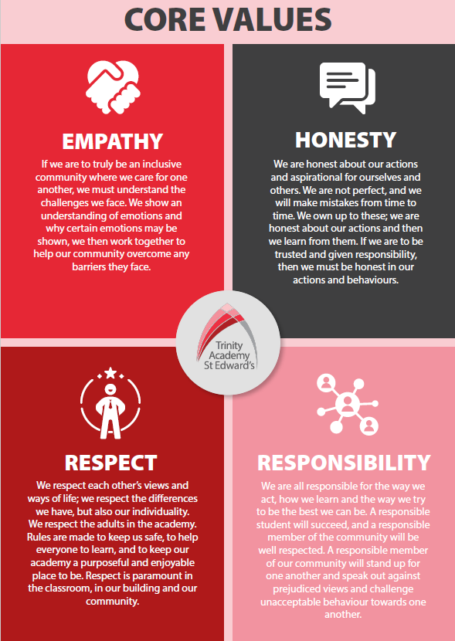

Trinity Academy St Edward’s

Job Description

Job Title: | Subject Co-ordinator
Job Scale: | MPR / UPR + TLR 2a

BASIC JOB PURPOSE

- To strategically lead the direction and development of the curriculum area in accordance with the aims and objectives of the academy.
- To raise standards of student attainment and achievement within the curriculum area by:
- ensuring the provision of an appropriately relevant and differentiated curriculum for all students.
- developing and enhancing the teaching practice of others.
- To effectively evaluate the impact of (b) and strategically plan for improvement by managing and deploying all financial and physical resources within the area.

Reporting to: | SLT Link
Responsible for: | Line management responsibility for identified teachers and/or support staff.
MAIN RESPONSIBILITIES

1 | To provide the strategic leadership across the area in accordance with the aims and objectives of the academy.
2 | To lead in the distribution of resources to ensure that the aims and objectives can be achieved.
3 | To monitor and evaluate the progress of students towards meeting the overall aims and objectives.
4 | To be responsible for student attainment in the area.
5 | To actively monitor and respond to curriculum development and initiatives at national, regional and local levels.
6 | To lead the development of appropriate syllabi, resources, SoW, assessment policies, and learning and teaching strategies in the area.
7 | To maintain accreditation with the relevant examination bodies.
8 | To establish common standards of practice within the academy and develop the effectiveness of teaching and learning styles.
9 | To keep up to date with national developments in teaching practice.
10 | To lead QA activities in line with academy policy.
11 | To ensure that staff development needs are identified and that appropriate programmes are designed to meet such needs.
12 | To be responsible for the efficient and effective deployment of any relevant associate, peripatetic and freelance staff.
13 | To participate in the academy’s ITT programme where appropriate.
14 | To evaluate the performance data provided and take appropriate action on issues arising - setting realistic deadlines where necessary and reviewing progress on the action taken.
15 | To produce reports on exam results both in terms of attainment & progress
16 | To ensure that all members of the academy are familiar with its aims and objectives.
17 | To ensure effective communication/consultation as appropriate with the parents of students and other relevant stakeholders.
18 | To liaise with partner schools, Higher Education Institutions, industrial links, Examination Boards/Awarding Bodies and other relevant external bodies.
19 | To represent the academy’s views and interests in a professional manner.
20 | To efficiently manage the available resources of space, staff, finance and equipment within the limits, guidelines and procedures laid down; to ensure that equipment and stock is requisitioned, organised and maintained, and appropriate records are kept.
21 | To ensure that the academy’s teaching commitments are effectively and efficiently timetabled.
22 | To monitor student attendance and progress in relation to targets set for each individual, ensuring that appropriate action is taken where necessary.
23 | To act as a Form Tutor and to carry out the duties associated with that role as outlined in the generic job description.
24 | To ensure the Behaviour Management System is implemented in the academy so that effective learning can take place.
25 | To contribute to academy liaison and marketing activities, e.g. the collection of material for press releases.
26 | To support the development of effective subject links with partner the community; attendance where necessary at liaison events in partner schools and the effective promotion of subjects at Open Days/Evenings/other events.
27 | To promote teamwork and to motivate staff to ensure effective working relations.
28 | To lead in the day-to-day line management of staff within the academy, ensuring that they follow academy policies and meet all requirements.
29 | To make appropriate arrangements for classes when staff are absent, liaising with the Cover staff where appropriate.

Other Specific Duties:

- All teachers are expected to meet the Teachers Standards, and demonstrate consistently high standards of personal and professional conduct, uphold public trust in the profession and maintain high standards of ethics and behaviour, within and outside school.

- To uphold and promote the academy’s Christian vision.

- Whilst every effort has been made to explain the main duties and responsibilities of the post, each individual task may not be identified. Employees will be expected to comply with any reasonable request from the principal to undertake work of a similar level that is not specified in this job description.

- This job description is current at the date shown. In consultation with you, it may be changed by the Principal to reflect or anticipate changes in the job commensurate with the grade and job title.

__________________________________________ Post Holder Name

__________________________________________ Post Holder Signature

______________________________________ Date

PERSON SPECIFICATION

Job Title: Subject Co-ordinator

KEY CRITERIA | ESSENTIAL | DESIRABLE
Qualifications & Experience | - Education to degree level or equivalent  - QTS and GTC registered  - An excellent track record of recent, relevant professional development  - Accountability for the performance of a cohort of young people  - Taking accountability for the success of an initiative  - Evidence of good/outstanding classroom practice  - Leadership of a community project or an area of school development  - Experience of effective teaching and performance within the curriculum area | - Innovative use of resources  - Working with young people and inner city communities
Knowledge & Understanding | - The principles and characteristics of effective academies  - Innovative approaches to working with students, parents, staff and the local community  - The principles and practices of strategic and operational planning and delivery  - Effective review and evaluation procedures  - The application of ICT to effective management | - Different methods of consulting with stakeholders  - Community/voluntary/parent/ partner agency links  - Strategies for ensuring equal opportunities for staff, students and other stakeholders
Leadership & Management | - Work effectively both as a leader and as a member of a team  - Initiate, lead and manage change  - Prioritise, plan and organise  - Direct and co-ordinate the work of others  - Set high standards and provide a role model for students and staff  - Deal sensitively with people and resolve conflicts  - Seek advice and support when necessary  - Prioritise and manage own time effectively  - A commitment to an open and collaborative style of management | - Motivate all those involved in the delivery team  - Liaise effectively with other organisations and agencies
Communication Skills | - Communicate the vision of the academy in relation to the development of the local community  - Negotiate and consult fairly and effectively  - Build relationships with key stakeholders  - Ability to communicate to a range of audiences  - Chair meetings effectively  - Communicate effectively orally and in writing to a range of audiences | - Develop, maintain and use an effective network of contacts
Decision Making Skills | - Make decisions based on analysis, interpretation and understanding of relevant data and information  - Demonstrate good judgement | - Think creatively and imaginatively to anticipate, identify and solve problems
Personal Qualities | - A commitment to inclusive education  - Evident enjoyment in working with young people and their families  - Empathy in relation to the needs of the academy and the local community  - Ability to inspire confidence in staff, students, parents and others  - Adaptability to changing circumstances/new ideas  - Reliability, integrity and stamina  - Personal impact and presence  - Work under pressure and to deadlines | - Vision, imagination and creativity  - A commitment to professional development

