Applicant Pack
Catering Assistant
- A welcome from the Principal
- Introduction to Trinity Academy St Edward’s
- Job Description
- Person Specification
ACADEMIC EXCELLENCE, AMAZING EXPERIENCE.
Part of the Trinity family of academies and schools

A welcome from the Principal
I am delighted that you are interested in working at our inimitable academy. Trinity Academy St Edward’s opened our doors in September 2021 to our founding cohort of students. This is an exciting and truly unique opportunity to be a key part of shaping the academy’s journey from the early conception. The academy is part of Trinity Multi Academy Trust and we will be very fortunate to benefit from outstanding support, guidance and resource from our highly successful trust. While benefitting from being part of this family we will continue to embed our culture and ethos from the start, ensuring every child achieves academic excellence and has an amazing experience.
The academy will serve communities from across Barnsley and no matter the starting point of our children we will raise their aspirations and change their futures by achieving outstanding outcomes and creating lifelong memories. Our broad and balanced curriculum, with a STEM focus, will open our students’ eyes to what the world can offer, and genuinely wide ranging extra-curricular experiences will dovetail this.
We are looking to recruit a Catering Assistant to join our fabulous team. Our school cohort is going to double from September, and we need passionate and hard-working colleagues to join our small catering team. If you have an interest in preparing and making food and have creative ideas for continually improving our menu, then this job really is for you. We have a strong culture that focuses purely on our children and these roles contribute significantly to our children’s day to day lives. We want only the best food and diet for our children, if children eat healthy diets and remain hydrated, we know the benefits are huge with concentration and learning in the classroom. We move to a brand new £25million, 18-acre site in the 2023-24 academic year and will a state-of-the-art kitchen and dining area. It really is an exciting time to be part of #TeamTrinity and I look forward to meeting candidates soon.
I am delighted and privileged to lead the academy and serve the communities of Barnsley. I am passionate about the future of the academy, its staff and students, and the change that we can make to the lives of the people of Barnsley. Our values of respect, honesty, empathy and responsibility will embody all we do in creating a happy, successful and ambitious culture at TASE.

Mark Allen
Principal

Trinity Academy St Edward’s
Due to an increase in population in Barnsley, particularly in young people of school age, the need for a new secondary school is prevalent. In 2019, Trinity Multi Academy Trust was selected by the Department for Education as the sponsor for a brand-new school.
Trinity MAT is proud to have transformed the life chances of thousands of students across its existing academies, and we are equipped and eager to do the same for those in Barnsley. Our MAT core values of Empathy, Honesty, Respect and Responsibility run through all aspects of academy life. We welcome students of all faiths and none, these values relate to everyone regardless of faith or background.
Drawing from the success and expertise of organisations across our high performing MAT, we will ensure that children are supported both academically and pastorally to secure the brightest of futures.
Our secondary schools consistently achieve academic results which place them in the top 10% of highest performing schools in the country and receive national and international recognition for the quality of their provision. This success will be replicated at Trinity Academy St Edward’s where every young person will benefit from outstanding teaching and an inspirational curriculum.
For more information about Trinity Academy St Edward’s please visit stedwards.trinitymat.org
For more information about Trinity Multi Academy Trust please visit www.trinitymat.org
‘An academy where ALL are respected and valued.’
We are a courageous, resilient and positive community rooted in hope, aspiration and excellence. Together, we enable each other to be the best we can be.
‘Whatever you do, work heartedly’ Colossians 3:23

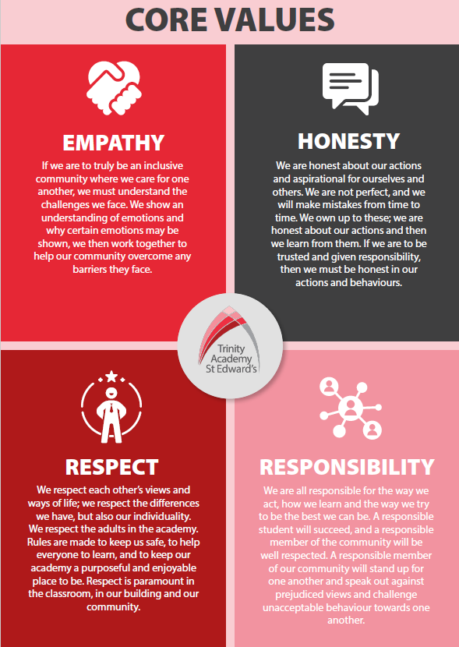

Trinity Academy St Edward’s

Job Description

Job Title: | Sports and Culture Coach
Job Scale: | Scale 5  37 hours a week. Term time plus 5 days.

BASIC JOB PURPOSE

- To support and drive an exceptional provision of sports education and experience.
- To complement the professional work of teachers by providing subject specific support to enhance the development, education and achievement of students.
- To work collaboratively with teaching staff (in the P.E. faculty and across the academy) and other support staff to develop effective and supportive relationships and routines.
- To run high quality extra-curricular provision for students within and outside of the academy day.
- To offer robust pastoral support to all students as a key part of the wider pastoral team.
- To model and promote the culture of excellence at the academy.
- To liaise with all relevant staff to support students’ progress and overall development.
- To support the academy and pastoral team to raise the aspirations/self-esteem of students.
- To contribute towards the effectiveness of the pastoral system across the academy/school.
- To implement and develop enrichment activities which contribute to students’ emotional and academic development.
- To support the academy’s Personal Development program.
- To liaise with staff, parents, other education institutions and multi-agency partners to support students’ progress and overall development.

Reporting to: |  | Associate Assistant Principal

Trinity Academy St Edward’s

Job Description

Job Title: | Catering Assistant
Job Scale: | Scale 1b (Points 1 – 2)

BASIC JOB PURPOSE
- To work as part of the Catering team to deliver a high-quality catering service for students, staff and visitors to the Academy.
- To oversee the lunchtime provision.
- To undertake, and carry out, work to a high and safe standard to ensure the smooth and safe running of the lunchtime provision.

Reporting to: | Deputy Catering Manager
Responsible for: | n/a

MAIN RESPONSIBILITIES

1 | Work as part of the catering team to take supervision in the form of receiving instructions, training, guiding, leading and assessment to ensure that quality food provision is delivered daily.
2 | Serve meals, in accordance with portion controls.
3 | Set up and clear restaurant dining and service area, including washing up, packing and uploading containers as required.
4 | Assist in the supervision of students.
5 | Clean the kitchen and dining premises, furniture and equipment (including the moving of supplies and equipment) as required to ensure standards of hygiene are maintained, e.g. boilers, deep fat fryers, walls and floors etc.
6 | To use all the equipment and machinery safety and efficiently after instruction.
7 | To report to the Catering Supervisor/Manager, any problems that may arise from customer dissatisfaction.
8 | Assist with simple cooking and reconstitution of food activities.
9 | To be available, if required, for emergency feeding and special, or evening functions.

Other Specific Duties:
- All staff are expected to demonstrate consistently high standards of personal and professional conduct and maintain high standards of ethics and behaviour, within and outside school.

- To uphold and promote the academy’s Christian vision.

- Treat all students with dignity, observe proper boundaries and understand that every adult in the academy has a responsibility to safeguard children and young people.

- To continue personal professional development as required

- Attend staff and other meetings and participate in staff training and development events as required

- To actively engage in the performance review process

- All support staff may be used to perform appropriate duties as and when required by the academy, commensurate with the salary grade of that post if it is higher than the employee’s current salary

- To work in the best interests of the academy, students, parents and staff

- To adhere to the academy’s policies and procedures with particular reference to Child Protection, Equal Opportunities, Teaching and Learning and Health and Safety

- To work flexibly, including some evening work, and to travel, as required, to meet the needs of the role

- To work at locations across the academy Trust, as required.

Whilst every effort has been made to explain the main duties and responsibilities of the post, each individual task undertaken may not be identified. Employees will be expected to comply with any reasonable request from a manager to undertake work of a similar level that is not specified in this job description.
This job description is current at the date shown, but, in consultation with you, may be changed by the Principal to reflect or anticipate changes in the job commensurate with the grade and job title.

__________________________________________ Post Holder Name

__________________________________________ Post Holder Signature

__________________________________________ Date

PERSON SPECIFICATION

Job Title: Catering Assistant
KEY CRITERIA | ESSENTIAL | DESIRABLE

Qualifications & Experience | - basic numeracy and literacy skills  - experience in a catering or kitchen role (paid or unpaid) | - catering qualifications (Level 2 award in food safety/catering – or equivalent)
Knowledge & Understanding | - knowledge of food preparation and food handling systems  - knowledge of basic cooking skills | - understanding of Safeguarding and Child Protection issues.
Skills & Abilities | - work as an effective team member and apply given instructions  - able to apply written and verbal instructions to equipment  - practical skills, such as cooking, food preparation  - able to complete log books, records, such as H&S checks  - able to organise, plan and complete tasks  - high personal standards and able to provide a role model for students and staff  - seek support and advice when necessary | - willingness to develop own understanding through advice and training  - think clearly in emergency situations
Personal Qualities | - enjoyment in working with young people and families  - an excellent record of attendance and punctuality  - prioritise and manage own time effectively | - reliability, integrity and stamina  - respect confidentiality

