Applicant Pack
General Administrator/SEND
- A welcome from the Principal
- Introduction to Trinity Academy St Edward’s
- Job Description
- Person Specification
ACADEMIC EXCELLENCE, AMAZING EXPERIENCE.
Part of the Trinity family of academies and schools

A welcome from the Principal
I am delighted that you are interested in working at our inimitable academy. Trinity Academy St Edward’s opened our doors in September 2021 to our founding cohort of students. This is an exciting and truly unique opportunity to be a key part of shaping the academy’s journey from the early conception. The academy is part of Trinity Multi Academy Trust and we will be very fortunate to benefit from outstanding support, guidance and resource from our highly successful trust. While benefitting from being part of this family we will continue to embed our culture and ethos from the start, ensuring every child achieves academic excellence and has an amazing experience.
The academy will serve communities from across Barnsley and no matter the starting point of our children we will raise their aspirations and change their futures by achieving outstanding outcomes and creating lifelong memories. Our broad and balanced curriculum, with a STEM focus, will open our students’ eyes to what the world can offer, and genuinely wide ranging extra-curricular experiences will dovetail this.
We are looking to recruit a General Administrator/SEND administrator to join our growing team. It is a very exciting time to be part of #TeamTrinity as we will welcome our second cohort in September and build on the superb foundations we have laid this year. This role will enable the successful applicant to contribute to the wider admin team and work closely with the PA to the Principal. Specifically, the role will support the very important work of the SENDCo. As an inclusive school we have a proportion of children who have extra needs and this role will require the successful candidate to support the SENDCo in the organisation and administration of all the statutory requirements for children with SEND needs. If you are child-centred, driven and passionate about changing the lives of children, this role is for you. Being part of #TeamTrinity gives you access to professional development as part of a successful and high performing Trust, and a commitment from the academy to invest in you as a person and make your job and your working environment a pleasure. I look forward to speaking to you and meeting you soon.
I am delighted and privileged to lead the academy and serve the communities of Barnsley. I am passionate about the future of the academy, our staff and students, and the change that we can make to the lives of the people of Barnsley. Our values of respect, honesty, empathy and responsibility will embody all we do in creating a happy, successful and ambitious culture at TASE.

Mark Allen
Principal

Trinity Academy St Edward’s
Due to an increase in population in Barnsley, particularly in young people of school age, the need for a new secondary school is prevalent. In 2019, Trinity Multi Academy Trust was selected by the Department for Education as the sponsor for a brand-new school.
Trinity MAT is proud to have transformed the life chances of thousands of students across its existing academies, and we are equipped and eager to do the same for those in Barnsley. Our MAT core values of Empathy, Honesty, Respect and Responsibility run through all aspects of academy life. We welcome students of all faiths and none, these values relate to everyone regardless of faith or background.
Drawing from the success and expertise of organisations across our high performing MAT, we will ensure that children are supported both academically and pastorally to secure the brightest of futures.
Our secondary schools consistently achieve academic results which place them in the top 10% of highest performing schools in the country and receive national and international recognition for the quality of their provision. This success will be replicated at Trinity Academy St Edward’s where every young person will benefit from outstanding teaching and an inspirational curriculum.
For more information about Trinity Academy St Edward’s please visit stedwards.trinitymat.org
For more information about Trinity Multi Academy Trust please visit www.trinitymat.org
‘An academy where ALL are respected and valued.’
We are a courageous, resilient and positive community rooted in hope, aspiration and excellence. Together, we enable each other to be the best we can be.
‘Whatever you do, work heartedly’ Colossians 3:23

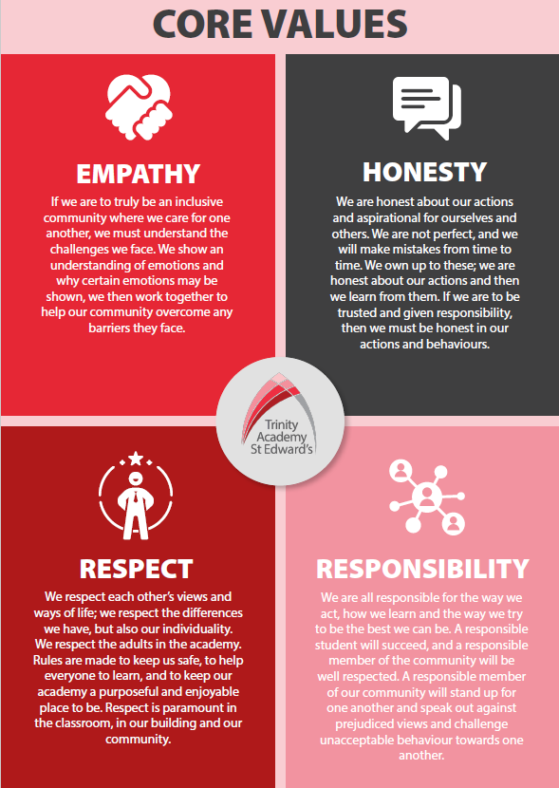

Trinity Academy St Edward’s

Job Description

Job Title: | Sports and Culture Coach
Job Scale: | Scale 5  37 hours a week. Term time plus 5 days.

BASIC JOB PURPOSE

- To support and drive an exceptional provision of sports education and experience.
- To complement the professional work of teachers by providing subject specific support to enhance the development, education and achievement of students.
- To work collaboratively with teaching staff (in the P.E. faculty and across the academy) and other support staff to develop effective and supportive relationships and routines.
- To run high quality extra-curricular provision for students within and outside of the academy day.
- To offer robust pastoral support to all students as a key part of the wider pastoral team.
- To model and promote the culture of excellence at the academy.
- To liaise with all relevant staff to support students’ progress and overall development.
- To support the academy and pastoral team to raise the aspirations/self-esteem of students.
- To contribute towards the effectiveness of the pastoral system across the academy/school.
- To implement and develop enrichment activities which contribute to students’ emotional and academic development.
- To support the academy’s Personal Development program.
- To liaise with staff, parents, other education institutions and multi-agency partners to support students’ progress and overall development.

Trinity Academy St Edward’s

Job Description

Job Title: | General Administrator/SEND
Job Scale: | Scale 3 (Point 5 - 6)

BASIC JOB PURPOSE
- To work as part of a team, providing a range of administrative support for internal and external customers
- To support the development of effective and efficient administration services
- Providing front of house/first point of contact services to visitors, parents, governors, students and staff
- To provide administration support services to contribute to the delivery of teaching and learning across the academy.
- To support the work of the SENDCo through administration of meeting notes, referrals and other key documentation
Reporting to: | PA to the Principal/SENDCo
Responsible for: | n/a
MAIN RESPONSIBILITIES
1 | To work as part of a team to provide customer focused services and a high quality, efficient administration support, using a range of IT packages and general office skills.
2 | To deal with enquiries from internal and external customers, particularly in regard to SEND needs of children
3 | To prioritise work to meet conflicting deadlines.
4 | To undertake administrative duties including preparing correspondence; taking minutes, dealing with hospitality, raise orders and monitoring stock supplies.
5 | To support the SENDCo by undertaking administrative duties in regard to SEND meetings organising and taking minutes of them and supporting the SENDCo with other administrative duties related to SEN Support Plans, EHCPs and One Page Profiles.
5 | To collate and prepare information from a variety of sources, including inputting and retrieving data using databases, or other applications.
6 | To communicate effectively with internal & external customers in relation to work undertaken.
7 | To work with others to help improve work organisation and effectiveness.
8 | To maintain accurate records and track progress of work.
9 | To assist in the training of new team members.
10 | To undertake any other administration duties to ensure the delivery of high quality teaching and learning.

 | Other Specific Duties:
- To continue personal professional development as required.

- Uphold and promote the academy’s Christian vision.

- Attend staff and other meetings and participate in staff training and development events as required.

- To actively engage in the performance review process.

- All support staff may be used to perform appropriate duties as and when required by the academy, commensurate with the salary grade of that post if it is higher than the employee’s current salary.

- To work in the best interests of the academy, students, parents and staff.

- To adhere to the Academy’s policies and procedures with particular reference to Child Protection, Equal Opportunities, Teaching and Learning and Health and Safety.

Whilst every effort has been made to explain the main duties and responsibilities of the post, each individual task undertaken may not be identified. Employees will be expected to comply with any reasonable request from a manager to undertake work of a similar level that is not specified in this job description.
This job description is current at the date shown, but, in consultation with you, may be changed by the Principal to reflect or anticipate changes in the job commensurate with the grade and job title.
__________________________________________ Post Holder

__________________________________________ Line Manager

__________________________________________ Principal

__________________________________________ Date

PERSON SPECIFICATION
Job: General Administrator/SEND

KEY CRITERIA |  | ESSENTIAL | DESIRABLE
Qualifications & Experience |  | - 4 or more GCSEs at grade C or above, including English and Maths (or equivalent)  - Evidence of experience in a similar, office or administration role  - Experience of working to deadlines  - Experience of note taking and arranging meetings  - Experience of using databases, word processing and a range of other IT packages | - Experience of working in a school environment (understanding of safeguarding and Child Protection issues)  - Experience of Bromcom  - Experience of working in SEND
Knowledge & Understanding |  | - Knowledge of administration systems and general office procedures  - Understanding of filing, storage and archive systems and procedures | - The potential uses of data to support efficiency  - Knowledge of SEND processes in a school setting
Skills & abilities |  | - Ability to communicate and negotiate effectively to a range of audiences (internal and external) through strong inter-personal, written, oral and presentation skills  - Sound judgment and ability to make decisions based on understanding of relevant information  - Able to prioritise work and to manage work to meet tight deadlines  - Adaptability to changing circumstances/ideas  - Work as an effective team member and apply given instructions  - Customer service skills  - Able to apply written and verbal instructions  - Able to organise, plan and complete tasks  - Able to work in a school environment, around children and young people  - Able to work as part of a team  - High personal standards and able to provide a role model for students and staff  - Seek support and advice when necessary | - Negotiate and consult fairly and effectively  - Deal sensitively with people and resolve conflicts  - Able to develop and maintain effective communication systems
Personal Qualities |  | - Adaptability to changing circumstances/new ideas  - Ability to inspire confidence in staff, students, parents and others  - Reliability and integrity and a commitment to confidentiality | - Determination to succeed and the highest possible expectations of self and others  - A commitment to inclusive education

