Applicant Pack
Learning Mentor – SEND & Pastoral Care
- A welcome from the Principal
- Introduction to Trinity Academy St Edward’s
- Job Description
- Person Specification
ACADEMIC EXCELLENCE, AMAZING EXPERIENCE.
Part of the Trinity family of academies and schools

A welcome from the Principal
I am delighted that you are interested in working at our inimitable academy. Trinity Academy St Edward’s opened our doors in September 2021 to our founding cohort of students. This is an exciting and truly unique opportunity to be a key part of shaping the academy’s journey from the early conception. The academy is part of Trinity Multi Academy Trust and we will be very fortunate to benefit from outstanding support, guidance and resource from our highly successful trust. While benefitting from being part of this family we will continue to embed our culture and ethos from the start, ensuring every child achieves academic excellence and has an amazing experience.
The academy will serve communities from across Barnsley and no matter the starting point of our children we will raise their aspirations and change their futures by achieving outstanding outcomes and creating lifelong memories. Our broad and balanced curriculum, with a STEM focus, will open our students’ eyes to what the world can offer, and genuinely wide ranging extra-curricular experiences will dovetail this.
We are looking to recruit a passionate, drive and child-centred Learning Mentor to support the work of the pastoral team and SENDCo in delivering a fully inclusive offer. It is a very exciting time to be part of #TeamTrinity as we will welcome our second cohort in September and build on the superb foundations we have laid this year. We are looking for either an experienced learning mentor, or current pastoral colleague to provide this level of support for our children, we welcome applicants from Primary as well as Secondary phase. We would also welcome applications from any professional who is recently or newly qualified, as we will offer world-class training and development as part of this role. Our academy’s culture is purely focused on children and we are building this culture based on high expectations, high aspirations and no excuses. If you want to support children and help them to overcome barriers through implementation of specific interventions, and resilience, then this role is for you and I look forward to speaking to you and meeting you.
Being part of #TeamTrinity gives you access to professional development as part of a successful and high performing Trust, and a commitment from the academy to invest in you as a person and make your job and your working environment a pleasure.
I am delighted and privileged to lead the academy and serve the communities of Barnsley. I am passionate about the future of the academy, our staff and students, and the change that we can make to the lives of the people of Barnsley. Our values of respect, honesty, empathy and responsibility will embody all we do in creating a happy, successful and ambitious culture at TASE.

Mark Allen
Principal

Trinity Academy St Edward’s
Due to an increase in population in Barnsley, particularly in young people of school age, the need for a new secondary school is prevalent. In 2019, Trinity Multi Academy Trust was selected by the Department for Education as the sponsor for a brand-new school.
Trinity MAT is proud to have transformed the life chances of thousands of students across its existing academies, and we are equipped and eager to do the same for those in Barnsley. Our MAT core values of Empathy, Honesty, Respect and Responsibility run through all aspects of academy life. We welcome students of all faiths and none, these values relate to everyone regardless of faith or background.
Drawing from the success and expertise of organisations across our high performing MAT, we will ensure that children are supported both academically and pastorally to secure the brightest of futures.
Our secondary schools consistently achieve academic results which place them in the top 10% of highest performing schools in the country and receive national and international recognition for the quality of their provision. This success will be replicated at Trinity Academy St Edward’s where every young person will benefit from outstanding teaching and an inspirational curriculum.
For more information about Trinity Academy St Edward’s please visit stedwards.trinitymat.org
For more information about Trinity Multi Academy Trust please visit www.trinitymat.org
‘An academy where ALL are respected and valued.’
We are a courageous, resilient and positive community rooted in hope, aspiration and excellence. Together, we enable each other to be the best we can be.
‘Whatever you do, work heartedly’ Colossians 3:23
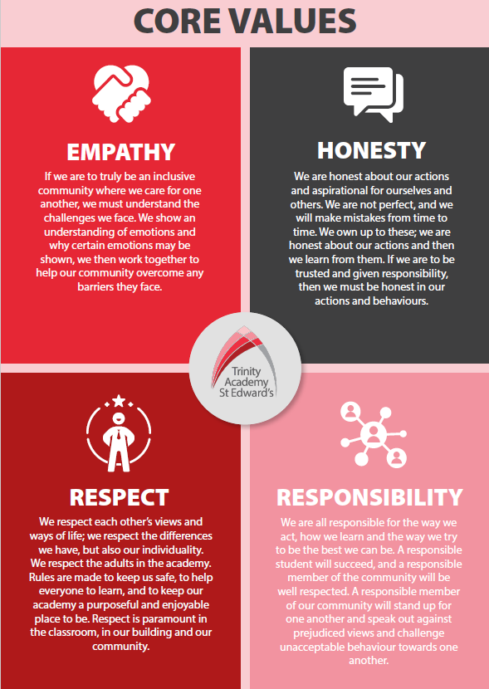

Trinity Academy St Edward’s

Job Description

Job Title: | Learning Mentor – SEND and pastoral care
Job Scale: | Scale 5 (Point 12-17)

BASIC JOB PURPOSE
- To complement the professional work of teachers by providing subject specific support to enhance the development, education and achievement of identified students
- To work collaboratively with teaching staff (in the subject area and across the academy) and other support staff to develop effective and supportive mentoring relationships
- To meet the specific needs of individual students, or a small group of students, as directed by the SENDCo and Inclusion Lead
- To assess the needs of students and specialist skills to improve learning and behaviour needs
- To liaise with all relevant staff to support students’ progress and overall development

Reporting to: | SENDCO
Responsible for: | n/a
MAIN RESPONSIBILITIES
1 | To take responsibility for agreed learning activities, prepared and delivered under an agreed system of supervision. This may involve planning, preparing and research for individual students or groups.
2 | To establish productive mentoring relationships with students, acting as a role model and setting high expectations.
3 | To monitor students and assess, record and report student progress and development.
4 | To promote the inclusion and acceptance of all students in the academy by identifying barriers to learning and developing strategies to overcome these.
5 | To encourage and mentor students so they can interact, work co-operatively and ensure that they understand and are able to following academy’s Behaviour for Learning policies.
6 | To develop an understanding of the student tracking systems that are used across the academy and contribute to the assessment of learners throughout their learning, particularly transition points.
7 | Within an agreed system of supervision, plan intervention and pastoral/SEMH sessions that develop students’ skills, resilience and SEMH. Monitor and evaluate student responses and progress to these activities through a range of assessment and monitoring strategies against pre-determined objectives.
8 | To provide objective and accurate feedback and reports as required on student achievement, progress and other matters, ensuring the availability of appropriate evidence.
9 | To deliver local and national learning strategies e.g. literacy, numeracy and make effective use of opportunities provided by other learning activities to support the development of students’ skills
10 | To use ICT effectively to support learning activities and develop students’ competence and independence in its use
11 | To undertake class supervision for whole classes where required, delivering prepared work from the agreed schemes of work, under guidance and support of the classroom teacher and/or SENDCo.

Other Specific Duties:
- To continue personal professional development as required

- To uphold and promote the academy’s Christian vision

- Attend staff and other meetings and participate in staff training and development events as required

- To actively engage in the performance review process

- All support staff may be used to perform appropriate duties as and when required by the academy, commensurate with the salary grade of that post if it is higher than the employee’s current salary

- To work in the best interests of the academy, students, parents and staff

- To adhere to the academy’s policies and procedures with particular reference to Child Protection, Equal Opportunities, Teaching and Learning and Health and Safety

- Undertake the role of a Form Tutor when required to offer support and cover to particular year groups

Whilst every effort has been made to explain the main duties and responsibilities of the post, each individual task undertaken may not be identified. Employees will be expected to comply with any reasonable request from a manager to undertake work of a similar level that is not specified in this job description.

This job description is current at the date shown, but, in consultation with you, may be changed by the Principal to reflect or anticipate changes in the job commensurate with the grade and job title.

__________________________________________ Post Holder Name

__________________________________________ Post Holder Signature

__________________________________________ Date

PERSON SPECIFICATION

Job Title: Learning Mentor – SEND and Pastoral Care
KEY CRITERIA | ESSENTIAL | DESIRABLE
Qualifications & Experience | - 5 or more GCSEs (or equivalent) at C or better, including English and Maths  - proficient use of technology, (PC, internet, MS Office packages) and understanding its use in supporting effective teaching and learning.  - experience of teaching (or other relevant learning environments), covering groups or whole classes  - basic experience of planning, either for lessons or for extra-curricular/intervention activities  - basic experience of assessing student progress and contributing to assessment processes |  | - experience of working with young people with SEN  - deal sensitively with people and resolve conflicts  - degree within specialist area  - SEMH/behaviour training
Knowledge & Understanding | - understanding of equal opportunities issues  - basic knowledge of reward strategies and understanding how these could be applied  - innovative approaches to working with students, parents and multi-agency partners  - awareness and commitment to safeguarding and promoting the welfare of children and expecting all staff to share this commitment |  | - knowledge of the needs of SEN students in academic surroundings  - SEMH knowledge and experience
Skills & Abilities | - ability to work consistently, prioritise and delegate appropriately, to handle pressure and to work to deadlines  - ability to communicate clearly and sensitively, both orally and in writing, with pupils, parents/carers and staff  - ability to work in a team, and collaboratively with other staff  - think creatively and imaginatively to anticipate, identify and solve problems  - demonstrate good judgment  - readiness to accept and implement change, openness and willingness to learn and flexibility |  | - willingness to develop own understanding and capability through advice and training  - think clearly in emergency situations  - negotiate and consult fairly and effectively  - ability to interpret and analyse data  - achieve challenging professional goals
Personal Qualities | - an excellent record of attendance and punctuality  - commitment to learning  - resilience and perspective  - set high standards and provide a role model for students and staff  - seek advice and support when necessary |  | - reliability, integrity and stamina  - respect confidentiality

