Applicant Pack
Site Assistant
- A welcome from the Principal
- Introduction to Trinity Academy St Edward’s
- Job Description
- Person Specification
ACADEMIC EXCELLENCE, AMAZING EXPERIENCE.
Part of the Trinity family of academies and schools

A welcome from the Principal
I am delighted that you are interested in working at our inimitable academy. Trinity Academy St Edward’s opened our doors in September 2021 to our founding cohort of students. This is an exciting and truly unique opportunity to be a key part of shaping the academy’s journey from the early conception. The academy is part of Trinity Multi Academy Trust and we will be very fortunate to benefit from outstanding support, guidance and resource from our highly successful trust. While benefitting from being part of this family we will continue to embed our culture and ethos from the start, ensuring every child achieves academic excellence and has an amazing experience.
The academy will serve communities from across Barnsley and no matter the starting point of our children we will raise their aspirations and change their futures by achieving outstanding outcomes and creating lifelong memories. Our broad and balanced curriculum, with a STEM focus, will open our students’ eyes to what the world can offer, and genuinely wide ranging extra-curricular experiences will dovetail this.
We are looking to recruit a Site Assistant to join our successful and hard-working premises team. This role is crucial to ensuring that all of our children can learn in a safe and effective environment. Without an immaculate building and grounds and without functioning facilities no one can work or learn effectively.
Our premises team are an integral part of #TeamTrinity and ensure our learning environment is world-class. We have a five-star Health and Safety rating and take immense pride in how our building looks and feels. We are looking to recruit a colleague who has a desire to succeed in their role, who works hard, is a team player, and will put children at the heart of all they do. We will move to a brand new £25million pound 18-acre site in the academic year 2023-2024 and that will bring new ventures, new experiences and exciting challenges for the successful candidate to be part of.
I am delighted and privileged to lead the academy and serve the communities of Barnsley. I am passionate about the future of the academy, its staff and students, and the change that we can make to the lives of the people of Barnsley. Our values of respect, honesty, empathy and responsibility will embody all we do in creating a happy, successful and ambitious culture at TASE.
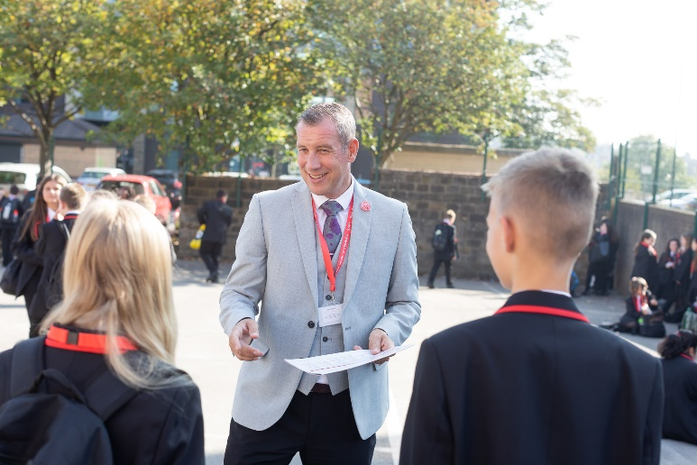
Mark Allen
Principal

Trinity Academy St Edward’s
Due to an increase in population in Barnsley, particularly in young people of school age, the need for a new secondary school is prevalent. In 2019, Trinity Multi Academy Trust was selected by the Department for Education as the sponsor for a brand-new school.
Trinity MAT is proud to have transformed the life chances of thousands of students across its existing academies, and we are equipped and eager to do the same for those in Barnsley. Our MAT core values of Empathy, Honesty, Respect and Responsibility run through all aspects of academy life. We welcome students of all faiths and none, these values relate to everyone regardless of faith or background.
Drawing from the success and expertise of organisations across our high performing MAT, we will ensure that children are supported both academically and pastorally to secure the brightest of futures.
Our secondary schools consistently achieve academic results which place them in the top 10% of highest performing schools in the country and receive national and international recognition for the quality of their provision. This success will be replicated at Trinity Academy St Edward’s where every young person will benefit from outstanding teaching and an inspirational curriculum.
For more information about Trinity Academy St Edward’s please visit stedwards.trinitymat.org
For more information about Trinity Multi Academy Trust please visit www.trinitymat.org
‘An academy where ALL are respected and valued.’
We are a courageous, resilient and positive community rooted in hope, aspiration and excellence. Together, we enable each other to be the best we can be.
‘Whatever you do, work heartedly’ Colossians 3:23

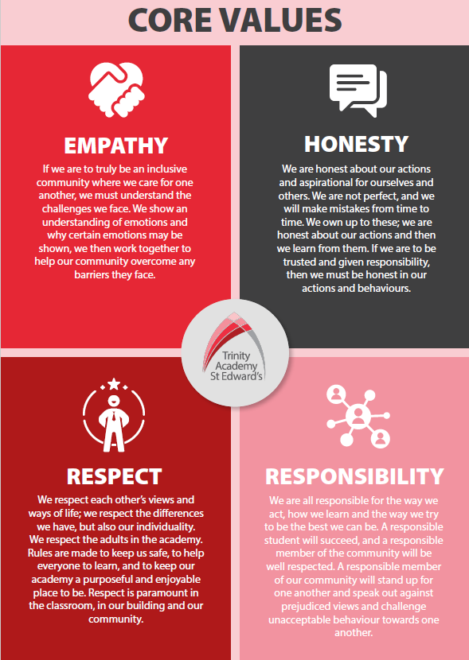

Trinity Academy St Edward’s

Job Description

Job Title: | Sports and Culture Coach
Job Scale: | Scale 5  37 hours a week. Term time plus 5 days.

BASIC JOB PURPOSE

- To support and drive an exceptional provision of sports education and experience.
- To complement the professional work of teachers by providing subject specific support to enhance the development, education and achievement of students.
- To work collaboratively with teaching staff (in the P.E. faculty and across the academy) and other support staff to develop effective and supportive relationships and routines.
- To run high quality extra-curricular provision for students within and outside of the academy day.
- To offer robust pastoral support to all students as a key part of the wider pastoral team.
- To model and promote the culture of excellence at the academy.
- To liaise with all relevant staff to support students’ progress and overall development.
- To support the academy and pastoral team to raise the aspirations/self-esteem of students.
- To contribute towards the effectiveness of the pastoral system across the academy/school.
- To implement and develop enrichment activities which contribute to students’ emotional and academic development.
- To support the academy’s Personal Development program.
- To liaise with staff, parents, other education institutions and multi-agency partners to support students’ progress and overall development.

Trinity Academy St Edward’s

Job Description

Job Title: | Site/Premises Assistant
Job Scale: | Scale 2 (Point 3 – 4)

BASIC JOB PURPOSE

- To work as part of the site team to ensure a safe working environment for students, staff and visitors to the Academy.
- To support the Premises manager to undertake, and carry out specific site and premises tasks.
- To carry out certain technical and administrative duties to ensure smooth and safe running of the site.
- To undertake, and carry out, work to a high and safe standard to ensure the smooth and safe of the site.

This role will involve manual labour, including moving supplies, equipment and cleaning equipment. Full Health and Safety training will be given.

Reporting to: | Premises Manager
Responsible for: | n/a
MAIN RESPONSIBILITIES

1 | Work as part of the site team to take supervision in the form of receiving instructions, training, guiding, leading and assessment to ensure that the site is maintained to high standards. To securely open and close the academy site on a daily basis.
2 | Moving furniture, equipment and other resources to ensure that teaching and learning activities are not interrupted.
3 | Set up, replenish and clear shared areas, including setting up for assemblies, moving rubbish, etc.
4 | Take part in outside site work, including some garden maintenance, sweeping, litter picking and grit spreading in winter months.
5 | Where directed, completing odd jobs and cleaning tasks to ensure that the site (inside and out) is safe and tidy.
6 | To use all the equipment and machinery safety and efficiently after instruction.
7 | To report to the Premises manager any problems that may arise from customer dissatisfaction.
8 | Assist with other staff in the academy in moving equipment and furniture.
9 | To be available, if required, for emergency situations and special, or evening functions.
10 | To be assist and support students, as necessary.
Other Specific Duties:

- To continue personal professional development as required.

- To uphold and promote the academy’s Christian vision.

- Attend staff and other meetings and participate in staff training and development events as required.

- To actively engage in the performance review process.

- All support staff may be used to perform appropriate duties as and when required by the academy, commensurate with the salary grade of that post if it is higher than the employee’s current salary.

- To work in the best interests of the Academy, students, parents and staff.

- To adhere to the Academy’s policies and procedures with particular reference to Child Protection, Equal Opportunities, Teaching and Learning and Health and Safety.

- To work flexibly, including some evening work, and to travel, as required, to meet the needs of the role.

Whilst every effort has been made to explain the main duties and responsibilities of the post, each individual task undertaken may not be identified. Employees will be expected to comply with any reasonable request from a manager to undertake work of a similar level that is not specified in this job description.

This job description is current at the date shown, but, in consultation with you, may be changed by the Principal to reflect or anticipate changes in the job commensurate with the grade and job title.
__________________________________________ Post Holder Signature

__________________________________________ Post Holder Name

__________________________________________ Date

PERSON SPECIFICATION

Job Title: Premises/Site Assistant

KEY CRITERIA |  | ESSENTIAL |  | DESIRABLE
Qualifications & Experience | - basic numeracy and literacy skills  - labouring or site maintenance experience  - experience in a site maintenance role (paid or unpaid) |  | - relevant qualifications (Level 2 or equivalent)
Knowledge & Understanding | - understanding of the nature of work in a manual site maintenance role.  - knowledge of basic caretaking skills |  | - understanding of Safeguarding and Child Protection issues.
Skills & Abilities | - work as an effective team member and apply given instructions  - able to apply written and verbal instructions to equipment  - practical skills, such as basic DIY, or other general maintenance skills.  - able to complete log books, records, such as H&S checks  - able to organise, plan and complete tasks  - high personal standards and able to provide a role model for students and staff  - seek support and advice when necessary |  | - willingness to develop own understanding through advice and training  - think clearly in emergency situations  - a skill or a trade

