Applicant Pack
Sports and Culture Coach
- A welcome from the Principal
- Introduction to Trinity Academy St Edward’s
- Job Description
- Person Specification
ACADEMIC EXCELLENCE, AMAZING EXPERIENCE.
Part of the Trinity family of academies and schools

A welcome from the Principal
I am delighted that you are interested in working at our inimitable academy. Trinity Academy St Edward’s opened our doors in September 2021 to our founding cohort of students. This is an exciting and truly unique opportunity to be a key part of shaping the academy’s journey from the early conception. The academy is part of Trinity Multi Academy Trust and we will be very fortunate to benefit from outstanding support, guidance and resource from our highly successful trust. While benefitting from being part of this family we will continue to embed our culture and ethos from the start, ensuring every child achieves academic excellence and has an amazing experience.
The academy will serve communities from across Barnsley and no matter the starting point of our children we will raise their aspirations and change their futures by achieving outstanding outcomes and creating lifelong memories. Our broad and balanced curriculum, with a STEM focus, will open our students’ eyes to what the world can offer, and genuinely wide ranging extra-curricular experiences will dovetail this.
We are looking to recruit an energetic, enthusiastic and sports-mad colleague to contribute to our thriving INVOLVE program, House system and to support the work of our talented Pastoral team. The successful candidate will be someone who has a real passion for sport and physical activity and who truly believes in the benefits of participation. The candidate will be skilled in one or more sports but have a thirst and drive to embed their love of sport in general to young children. Children are at the centre of all we do at Trinity Academy St Edward’s and the successful candidate will build strong relationships and ensure that our children receive the very best support alongside amazing experiences through participation, coaching and the spectating of sport. Our children love our House system and love the competition it brings. The successful candidate will take a lead in organising and running House events and use their contacts in sport and their experience to organise and lead exciting and innovative House events. They will form part of the new Physical Education team at Trinity Academy St Edward’s and work closely with our Deputy Curriculum Leader of PE to organise and run a multitude of extra-curricular clubs, matches and events.
This is truly a once in a lifetime chance for someone who loves sport, loves working with children and who will have the chance to innovate and contribute to a brand-new school. With a new £25 million, 18-acre new build on the horizon, bringing with it state-of-the-art facilities – there is no limit to what this role can offer now, and in the future. It will most certainly contribute to changing the lives of the children of Barnsley.
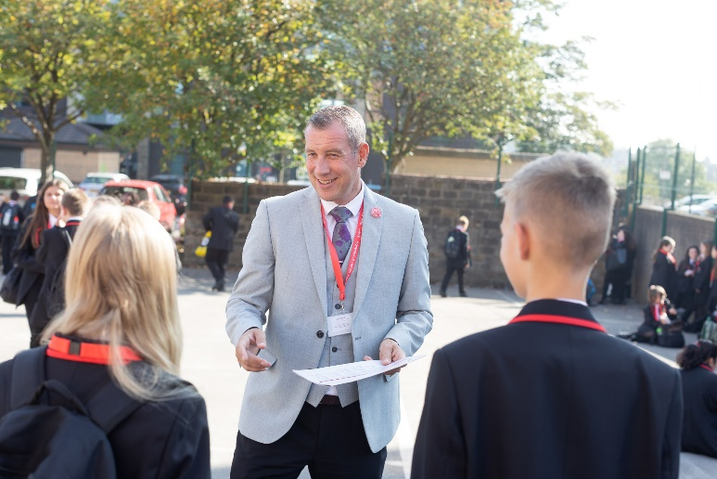
I am delighted and privileged to lead the academy and serve the communities of Barnsley. I am passionate about the future of the academy, its staff and students, and the change that we can make to the lives of the people of Barnsley. Our values of respect, honesty, empathy and responsibility will embody all we do in creating a happy, successful and ambitious culture at TASE.
Mark Allen
Principal

Trinity Academy St Edward’s
Due to an increase in population in Barnsley, particularly in young people of school age, the need for a new secondary school is prevalent. In 2019, Trinity Multi Academy Trust was selected by the Department for Education as the sponsor for a brand-new school.
Trinity MAT is proud to have transformed the life chances of thousands of students across its existing academies, and we are equipped and eager to do the same for those in Barnsley. Our MAT core values of Empathy, Honesty, Respect and Responsibility run through all aspects of academy life. We welcome students of all faiths and none, these values relate to everyone regardless of faith or background.
Drawing from the success and expertise of organisations across our high performing MAT, we will ensure that children are supported both academically and pastorally to secure the brightest of futures.
Our secondary schools consistently achieve academic results which place them in the top 10% of highest performing schools in the country and receive national and international recognition for the quality of their provision. This success will be replicated at Trinity Academy St Edward’s where every young person will benefit from outstanding teaching and an inspirational curriculum.
For more information about Trinity Academy St Edward’s please visit stedwards.trinitymat.org
For more information about Trinity Multi Academy Trust please visit www.trinitymat.org
‘An academy where ALL are respected and valued.’
We are a courageous, resilient and positive community rooted in hope, aspiration and excellence. Together, we enable each other to be the best we can be.
‘Whatever you do, work heartedly’ Colossians 3:23

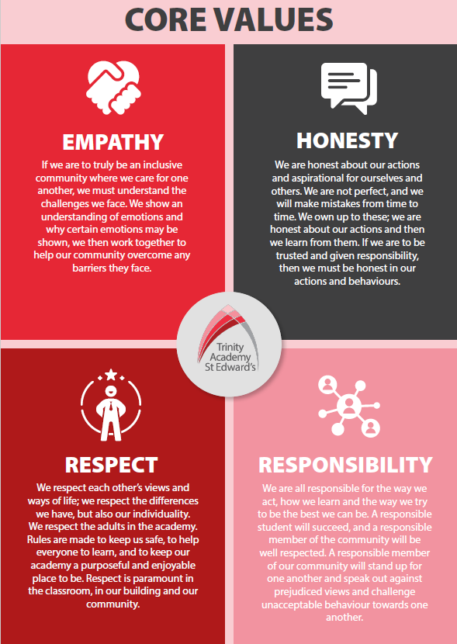

Trinity Academy St Edward’s

Job Description

Job Title: | Sports and Culture Coach
Job Scale: | Scale 5  37 hours a week. Term time plus 5 days.

BASIC JOB PURPOSE

- To support and drive an exceptional provision of sports education and experience.
- To complement the professional work of teachers by providing subject specific support to enhance the development, education and achievement of students.
- To work collaboratively with teaching staff (in the P.E. faculty and across the academy) and other support staff to develop effective and supportive relationships and routines.
- To run high quality extra-curricular provision for students within and outside of the academy day.
- To offer robust pastoral support to all students as a key part of the wider pastoral team.
- To model and promote the culture of excellence at the academy.
- To liaise with all relevant staff to support students’ progress and overall development.
- To support the academy and pastoral team to raise the aspirations/self-esteem of students.
- To contribute towards the effectiveness of the pastoral system across the academy/school.
- To implement and develop enrichment activities which contribute to students’ emotional and academic development.
- To support the academy’s Personal Development program.
- To liaise with staff, parents, other education institutions and multi-agency partners to support students’ progress and overall development.

Reporting to: | Associate Assistant Principal

Trinity Academy St Edward’s

Job Description

Job Title: | Sports and Culture Coach
Job Scale: | Scale 5  37 hours a week. Term time plus 5 days.

BASIC JOB PURPOSE

- To support and drive an exceptional provision of sports education and experience.
- To complement the professional work of teachers by providing subject specific support to enhance the development, education and achievement of students.
- To work collaboratively with teaching staff (in the P.E. faculty and across the academy) and other support staff to develop effective and supportive relationships and routines.
- To run high quality extra-curricular provision for students within and outside of the academy day.
- To offer robust pastoral support to all students as a key part of the wider pastoral team.
- To model and promote the culture of excellence at the academy.
- To liaise with all relevant staff to support students’ progress and overall development.
- To support the academy and pastoral team to raise the aspirations/self-esteem of students.
- To contribute towards the effectiveness of the pastoral system across the academy/school.
- To implement and develop enrichment activities which contribute to students’ emotional and academic development.
- To support the academy’s Personal Development program.
- To liaise with staff, parents, other education institutions and multi-agency partners to support students’ progress and overall development.

Reporting to: | Associate Assistant Principal
Responsible for: | N/A
MAIN RESPONSIBILITIES

1 | To take responsibility for agreed learning activities within and outside of the academy day.
2 | To encourage participation and enjoyment at extra-curricular sporting clubs and fixtures within academy’s extra-curricular program and beyond.
3 | To support the academy’s Behaviour for Learning system, providing training, advice and support and acting as a role model, in applying and using the policy. This includes actively demonstrating the understanding of the pastoral and behaviour policies and procedures to students, staff and parents.
4 | Prepare, plan and implement individual, group and some whole class learning activities and intervention programmes across the whole academy, working alongside and in conjunction with professional teaching staff, this could include assemblies.
5 | To support reward strategies that develop a culture of achievement, reward and responsibility within year groups .
6 | To support and liaise with key staff and from this, contact parents, make home visits and attend meetings with parents/carers of students who require intervention or other support.
7 | To remain informed and up to date around national initiatives and good practice as it relates to students and pastoral leadership and management.
8 | To implement and monitor specialist inclusion intervention strategies, and liaise with relevant outside agencies to support all students with special educational needs.
9 | To create strong links with contacts in the sports industry and the wider community to enhance the curriculum and culture of achievement within the academy
10 | To record and maintain accurate student records, e.g. registers in line with Data Protection legislation and following correct academy policy and procedures.

Other Specific Duties:
- All staff are expected to demonstrate consistently high standards of personal and professional conduct and maintain high standards of ethics and behaviour, within and outside school.

- To uphold and promote the academy’s Christian vision.

- Treat all students with dignity, observe proper boundaries and understand that every adult in the academy has a responsibility to safeguard children and young people.

- To continue personal professional development as required

- Attend staff and other meetings and participate in staff training and development events as required

- To actively engage in the performance review process

- All support staff may be used to perform appropriate duties as and when required by the academy, commensurate with the salary grade of that post if it is higher than the employee’s current salary

- To work in the best interests of the Trust, the academy and its students, staff and parents

- To adhere to the academy’s policies and procedures with particular reference to Child Protection, Equal Opportunities, Teaching and Learning and Health and Safety

- To work flexibly, including some evening work, and to travel, as required, to meet the needs of the role

- To work at locations across the Trust, as required.

Whilst every effort has been made to explain the main duties and responsibilities of the post, each individual task undertaken may not be identified. Employees will be expected to comply with any reasonable request from a manager to undertake work of a similar level that is not specified in this job description.

This job description is current at the date shown, but, in consultation with you, may be changed by the line manager to reflect or anticipate changes in the job commensurate with the grade and job title.

_______________________________________________Print Name

__________________________________________ Signature

__________________________________________ Date

PERSON SPECIFICATION
Job Title: Sports and Culture Coach

KEY CRITERIA | ESSENTIAL | DESIRABLE
Qualifications and experience | - at least 5 or more GCSE’s including English and Maths at grade C or above (or equivalent)  - experience of successfully working with young people  - experience of working in sporting context  - experience of successfully organising, participating or supporting with a range of different sports  - experience of forging community/voluntary/ parent and partner agency links |  | - Educated to degree level  - Achievements within sport at a high level, working with young people within a sporting context  - Qualifications in Physical Education, Coaching and Sport  - Experience as referee  - Mini bus license
Knowledge and understanding | - understanding of the benefits and wider positives of participation in Sport for young people  - understanding of students’ welfare and pastoral needs  - strategies for ensuring equal opportunities for students, staff and other stakeholders  - ability to participate professionally in meetings |  | - understanding of Safeguarding and Child Protection issues  - Links with sporting partners
Skills and abilities | - ability to communicate effectively through highly developed inter-personal written, verbal and presentation skills to a range of audiences  - work as an effective team member and apply given instructions  - prioritise, plan and direct the workload of self-balancing long and short-term priorities  - set high standards and provide a role model for students and staff  - well-developed analytical, planning and organisational skills  - demonstrate a willingness to take the initiative  - identify and develop creative and imaginative solutions to solve problems  - seek support and advice when necessary  - demonstrable ability to evaluate work programs and strategies  - evidence of sound judgment skills |  | - willingness to develop own understanding and capability through advice and training  - think clearly in emergency situations
Personal qualities | - high standards for excellence at all times  - a love of sport and engaging young people in sport  - positive, flexible, energetic, can do attitude  - enjoyment in working with young people and families  - an excellent record of attendance and punctuality  - commitment to inclusive education  - commitment to learning  - resilience and perspective |  | - reliability, integrity and stamina  - respect confidentiality

