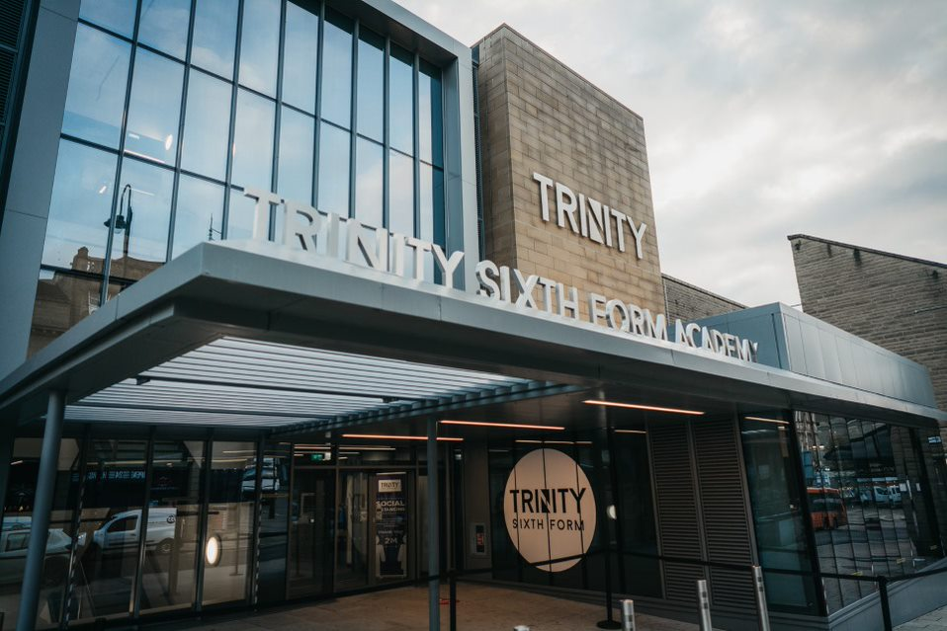
Welcome to TSFA
Job Description and Person Specification:
Specialist Site Assistant

Trinity Sixth Form Academy

Job Description

Job Title: | Specialist Site Assistant
Job Scale: | Scale 4 (Point 7 - 11)

BASIC JOB PURPOSE

- To support the Premises Manager to undertake, and carry out, efficient maintenance of the building and the site.
- To carry out certain technical and administrative duties to ensure smooth and safe running of the building and site.
- To undertake, and carry out, certain manual and repair work to a high standard to ensure the smooth and safe running of the building and site.
- To undertake work at the academy relating to a specific trade.

This role will involve manual labour, including moving, lifting and repairing furniture and fittings. Full Health and Safety training will be given.

Reporting to: | Premises Manager
Responsible for: | n/a

MAIN RESPONSIBILITIES

1 | To support the Premises Manager to maintain the buildings and amenities of the Academy, carrying out all necessary repairs and improvements. (General repairs and trade specific repairs and maintenance).
2 | To support the Premises Manager, to manage, schedule, monitor and operate the engineering system for the entire site, including all aspects of the heating installation.
3 | To support the Premises Manager to design and draw up plans and specifications, including costs, for minor alterations to premises and specifications for maintenance work to be carried out by contractors.
4 | To maintain and regularly monitor Health and Safety standards, reporting any failures to comply with the Academy’s statutory obligations in this area and ensure that all work on site meets Health and Safety Regulations.
5 | Liaise with external partners and contractors in respect of buildings works at the Academy. This includes having due regard for safety and security procedures.
7 | To support the Premises team to manage and operate appropriate site security systems, including opening and closing at the beginning and end of the Academy day, responding to call-outs, etc; in order to ensure satisfactory security arrangements.
8 | To maintain and monitor Risk Assessment standards, reporting any failures to comply with the Academy’s statutory obligations in this area and ensure that all trips meet Risk Assessment Regulations.
9 | To deputise, when needed, on the operational supervision of the cleaning staff on the Academy site, including arranging work schedules, monitoring cleaning duties, order supplies of cleaning materials and other materials, and identify staff training needs; in order to achieve quality work and the most effective deployment and competence of staff.

Other Specific Duties:

- All staff are expected to demonstrate consistently high standards of personal and professional conduct and maintain high standards of ethics and behaviour, within and outside school.

- Treat all students with dignity, observe proper boundaries and understand that every adult in the academy has a responsibility to safeguard children and young people.

- To continue personal professional development as required

- Attend staff and other meetings and participate in staff training and development events as required

- To actively engage in the performance review process

- All support staff may be used to perform appropriate duties as and when required by the academy, commensurate with the salary grade of that post if it is higher than the employee’s current salary

- To work in the best interests of the academy, students, parents and staff

- To adhere to the academy’s policies and procedures with particular reference to Child Protection, Equal Opportunities, Teaching and Learning and Health and Safety

- To work flexibly, including some evening work, and to travel, as required, to meet the needs of the role

- To work at locations across the academy Trust, as required.

Whilst every effort has been made to explain the main duties and responsibilities of the post, each individual task undertaken may not be identified. Employees will be expected to comply with any reasonable request from a manager to undertake work of a similar level that is not specified in this job description.

This job description is current at the date shown, but, in consultation with you, may be changed by the Principal to reflect or anticipate changes in the job commensurate with the grade and job title.

__________________________________________ Post Holder Name

__________________________________________ Post Holder Signature

__________________________________________ Date

PERSON SPECIFICATION

Job Title: Specialist Site Assistant

KEY CRITERIA | ESSENTIAL | DESIRABLE
Qualifications & Experience | - basic numeracy and literacy skills  - caretaking or site maintenance experience  - experience in a manual labour role (paid or unpaid)  - qualification/s or proven experience in a skill or trade. | - Health and Safety related qualifications
Knowledge & Understanding | - knowledge of security systems  - understanding of safety and security  - knowledge of Health and Safety processes and procedures. | - understanding of Safeguarding and Child Protection issues
Skills & Abilities | - work as an effective team member and apply given instructions  - able to apply written and verbal instructions to equipment  - practical skills, such as basic maintenance, building skills (Handyperson skills)  - able to complete log books, records, such as H&S checks  - able to organise, plan and complete tasks  - high personal standards and able to provide a role model for students and staff  - seek support and advice when necessary | - willingness to develop own understanding through advice and training  - think clearly in emergency situations
Personal Qualities | - enjoyment in working with young people and families  - an excellent record of attendance and punctuality  - prioritise and manage own time effectively | - reliability, integrity and stamina  - respect confidentiality

