Applicant Pack
Student Liaison Officer
- A welcome from the Principal
- Introduction to Trinity Academy St Edward’s
- Job Description
- Person Specification
ACADEMIC EXCELLENCE, AMAZING EXPERIENCE.

Part of the Trinity family of academies and schools

A welcome from the Principal
I am delighted that you are interested in working at our inimitable academy. Trinity Academy St Edward’s opened our doors in September 2021 to our founding cohort of students. This is an exciting and truly unique opportunity to be a key part of shaping the academy’s journey from the early conception. The academy is part of Trinity Multi Academy Trust and we will be very fortunate to benefit from outstanding support, guidance and resource from our highly successful trust. While benefitting from being part of this family we will continue to embed our culture and ethos from the start, ensuring every child achieves academic excellence and has an amazing experience.
The academy serves communities from across Barnsley and no matter the starting point of our children we will raise their aspirations and change their futures by achieving outstanding outcomes and creating lifelong memories. Our broad and balanced curriculum, with a STEM focus, will open our students’ eyes to what the world can offer, and genuinely wide ranging extra-curricular experiences will dovetail this.
We are now looking to recruit a committed, and proactive Student Liaison Officer to a strong, effective, and united pastoral team. The role of Student Liaison Officer will be key in supporting our children in making the right choices, in working hard and in being kind; helping them to achieve and flourish at our academy. If you are passionate about working with children, being a positive role model and helping to shape the lives of children, this is the role for you. A pastoral leader at our academy needs to live and breathe high expectations and ‘go the extra mile’ to support, inspire and form relationships of mutual trust and respect with our children. We do not accept excuses, we work together with children, their families and external agencies to ensure all succeed regardless of stating point or situation. Children are at our dead centre; every decision and all of our efforts are for them.
This is truly a once in a lifetime chance for someone who has a passion for pastoral care, who loves working with children to add to and innovate with our other pastoral leaders. During next academic year we move to a brand-new school; a new £25 million, 18-acre new build, bringing with it state-of-the-art facilities – there is no limit to what this role can offer now, and in the future. It will most certainly contribute to changing the lives of the children of Barnsley.
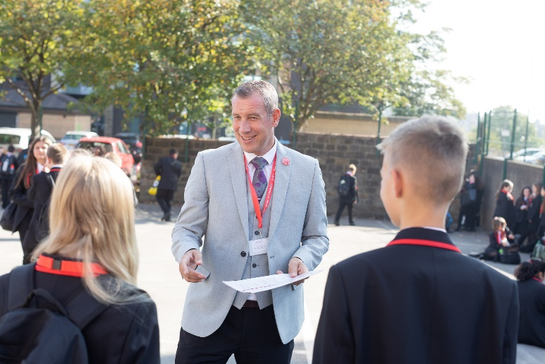
I am delighted and privileged to lead the academy and serve the communities of Barnsley. I am passionate about the future of the academy, our staff and students, and the change that we can make to the lives of the people of Barnsley. Our values of respect, honesty, empathy and responsibility embody all we do in creating a happy, successful and ambitious culture at TASE.

Mark Allen
Principal

Trinity Academy St Edward’s
Due to an increase in population in Barnsley, particularly in young people of school age, the need for a new secondary school is prevalent. In 2019, Trinity Multi Academy Trust was selected by the Department for Education as the sponsor for a brand-new school.
Trinity MAT is proud to have transformed the life chances of thousands of students across its existing academies, and we are equipped and eager to do the same for those in Barnsley. Our MAT core values of Empathy, Honesty, Respect and Responsibility run through all aspects of academy life. We welcome students of all faiths and none, these values relate to everyone regardless of faith or background.
Drawing from the success and expertise of organisations across our high performing MAT, we will ensure that children are supported both academically and pastorally to secure the brightest of futures.
Our secondary schools consistently achieve academic results which place them in the top 10% of highest performing schools in the country and receive national and international recognition for the quality of their provision. This success will be replicated at Trinity Academy St Edward’s where every young person will benefit from outstanding teaching and an inspirational curriculum.
For more information about Trinity Academy St Edward’s please visit stedwards.trinitymat.org
For more information about Trinity Multi Academy Trust please visit www.trinitymat.org
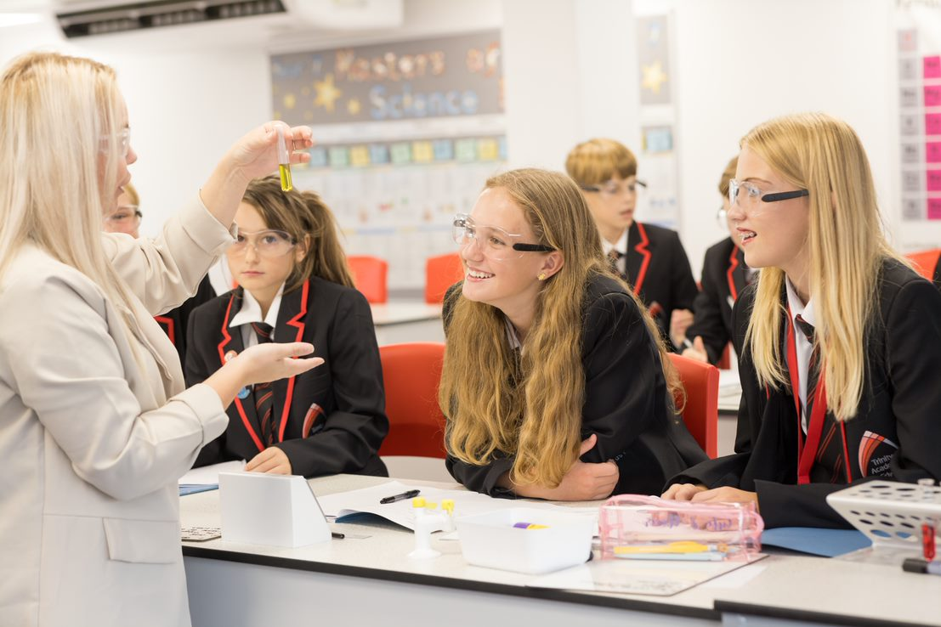

‘An academy where ALL are respected and valued.’
We are a courageous, resilient and positive community rooted in hope, aspiration and excellence. Together, we enable each other to be the best we can be.
‘“The one who gets wisdom loves life; the one who cherishes understanding will soon prosper.” Proverbs 19:8

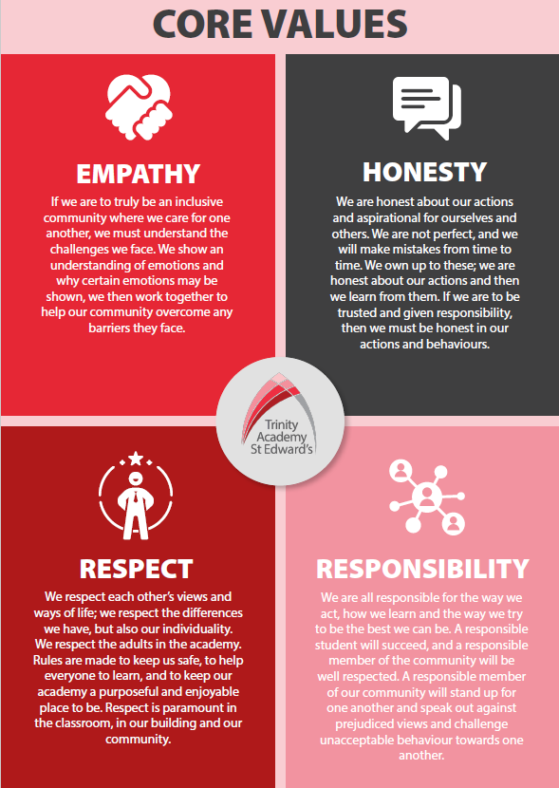

Trinity Academy St Edward’s

Job Description

Job Title: | Student Liaison Officer (SLO)
Job Scale: | Scale 6 (Points 18 - 22)

BASIC JOB PURPOSE

- To provide leadership and operational management to an assigned pastoral year group to raise the aspirations/self-esteem of students.
- To contribute towards the strategic leadership of the pastoral system across the academy/school.
- To implement and develop enrichment activities which contribute to students’ emotional and academic development.
- To implement and develop programmes of support for identified students, working in collaboration with other pastoral and SEN staff, by fostering strong relationships across the academy community.
- To develop programmes which focus on students’ attitudinal and academic development as identified through relevant evaluation and improvement planning.
- To use academic data from internal and external sources to plan, implement and evaluate support interventions for students.
- To liaise with staff, parents, other education institutions and multi-agency partners to support students progress and overall development.

Reporting to: | Lead Teacher - Pastoral
Responsible for:

MAIN RESPONSIBILITIES

1 | To provide leadership and management to the year group ensuring that all learners are guided, as appropriate and that their progress is regularly monitored and reviewed.
2 | To use, model and evaluate effective practice and quality assure the processes and systems of self-review, student reviews and working with other staff and agencies who support students (including Local Authority and Government Agencies, Health and Children’s Services, Voluntary Groups and Parent and Carer Organisations) to ensure effective communication concerning the maintenance of students’ wellbeing.
3 | To support the academy/school Behaviour for Learning system, providing training, advice and support and acting as a role model, in applying and using the policy. This includes actively demonstrate understanding of pastoral and behavior policy and procedures to students, staff and parents.
4 | To lead year-group team meetings, leading the sharing of information and ideas, and positively promoting and providing guidance on academy/school policy and procedures to tutors. Where there are areas of concern, or potential underperformance with a tutor(s), seek advice and support.
5 | To access, maintain and update a range of student and academy/school records to assess students’ progress and monitor the overall experience of students in the year group to ensure equal opportunity to all, attendance and other key indicators are in line with academy targets.
6 | To lead on strategies that develop and improve the pastoral system through monitoring and evaluating the quality of tutor sessions, and student engagement, through data analysis, learning walks, surveys and other evaluation methods.
7 | To access, monitor and analyse student data to ensure that student tracking is effectively managed across the academy and that learners are informed and advised appropriately throughout their learning, particularly transition points.
8 | Prepare, plan and implement individual, group and some whole class learning activities and intervention programmes across the whole academy/school, working alongside and in conjunction with professional teaching staff, including assemblies.
9 | To research, arrange and assess reward strategies that develop a culture of achievement, reward and responsibility within the year group.
10 | To support and liaise with the key staff (i.e. Phase Leaders, Welfare Officers, Attendance Officer) by contacting parents, making home visits and attending meetings with parents/carers of students who require intervention or other support.
11 | To remain informed and up to date around national initiatives and good practice as it relates to students and pastoral leadership and management.
12 | To implement and monitor specialist inclusion intervention strategies, and liaise with relevant outside agencies to support all students with special educational needs.
 | To create strong links with the wider community to enhance the curriculum and culture of achievement
14 | To make decisions on internal exclusions in liaison with the SLG link.
15 | To record and maintain accurate student records, in line with Data Protection legislation and policy and procedures.

Other Specific Duties:
- All staff are expected to demonstrate consistently high standards of personal and professional conduct and maintain high standards of ethics and behaviour, within and outside school.

- Treat all students with dignity, observe proper boundaries and understand that every adult in the academy has a responsibility to safeguard children and young people.

- To continue personal professional development as required

- Attend staff and other meetings and participate in staff training and development events as required

- To actively engage in the performance review process

- All support staff may be used to perform appropriate duties as and when required by the academy, commensurate with the salary grade of that post if it is higher than the employee’s current salary

- To work in the best interests of the academy Trust, students, parents and staff

- To adhere to the academy’s policies and procedures with particular reference to Child Protection, Equal Opportunities, Teaching and Learning and Health and Safety

- To work flexibly, including some evening work, and to travel, as required, to meet the needs of the role

- To work at locations across the academy Trust, as required.

Whilst every effort has been made to explain the main duties and responsibilities of the post, each individual task undertaken may not be identified. Employees will be expected to comply with any reasonable request from a manager to undertake work of a similar level that is not specified in this job description.

This job description is current at the date shown, but, in consultation with you, may be changed by the line manager to reflect or anticipate changes in the job commensurate with the grade and job title.

PERSON SPECIFICATION
Job Title: Student Liaison Officer

KEY CRITERIA | ESSENTIAL |  | DESIRABLE
Qualifications and experience | - education to A Level standard or equivalent relevant experience  - experience of successfully working with identified disaffected students, or groups of students  - experience of monitoring and recording progress of learners  - experience of forging community/voluntary/ parent and partner agency links  - experience of working with young people with SEN or behavioural issues  - experience of leading or managing a team | - leadership of a community project/area of school development
Knowledge and understanding | - understanding of students welfare and pastoral needs  - innovative approaches to working with students, parents, the local community and multi-agency partners in relation to inclusion, behaviour and reward strategies  - strategies for ensuring equal opportunities for students, staff and other stakeholders  - ability to participate professionally in meetings | - understanding of Safeguarding and Child Protection issues  - knowledge of the needs of SEN students in academic surroundings
Skills and abilities | - ability to communicate effectively, negotiate and network through highly developed inter-personal written, verbal and presentation skills to a range of audiences, including SLG and governors  - work as an effective team member and apply given instructions  - prioritise, plan and direct the workload of self and others, balancing long and short term priorities  - set high standards and provide a role model for students and staff  - well-developed analytical, planning and organisational skills  - demonstrate a willingness to take the initiative  - identify and develop creative and imaginative solutions to solve problems  - seek support and advice when necessary  - deal with student’s personal and other crises  - demonstrable ability to evaluate work programmes and strategies  - evidence of sound judgment skills | - willingness to develop own understanding and capability through advice and training  - think clearly in emergency situations
Personal qualities | - enjoyment in working with young people and families.  - an excellent record of attendance and punctuality  - commitment to inclusive education  - commitment to learning  - resilience and perspective  - respect confidentiality | - reliability, integrity and stamina

